Contents

DATA CLASSIFICATION 4

DATA FORMAT 4

TERMINOLOGIES 4

DATA LAKE 4

DATALAKE KEY CONCEPTS 4

DATA INGESTION 5

DATA STORAGE 5

DATA GOVERNANCE 5

SECURITY 5

DATA QUALITY 6

DATA DISCOVERY 6

DATA AUDITING 6

DATA LINEAGE 6

DATA EXPLORATION 6

AZURE DATA LAKE STORAGE ACCOUNT 6

CREATING DATA LAKE GEN-2 STORAGE ACCOUNT 7

CREATING CONTAINIER AND UPLOAD BLOB OBJECTS 8

CONNECTING STORAGE EXPLORER WITH DATA LAKE STORAGE ACCOUNT 9

RELATIONAL DATABASE IN AZURE 9

ACID PROPERTY OF RELATIONAL DATABASE 10

EXAMPLES 10

AZURE OFFERING FOR RELATIONAL DATABASE(PAAS) 10

AZURE SQL DATABASE 10

DEPLOYMENT MODEL OF SQL DATABASE 10

CREATING SQL DATABASE 11

CONFIGURING THE DATABASE 12

NETWORKING 13

ADDITIONAL SETTINGS 13

ELASTIC POOL IN SQL DATABASE 14

CONFIGURING SQL SERVER STUDIO 14

USE CASE (BATCH OPERATION) 15

PARAMETERIZING THE PIPELINE 21

ETL(EXTRACT-TRANSFORM-LOAD) 27

AZURE SYNAPSE ANALYTICS 27

AZURE DATA FACTORY 27

WHAT PROBLEM DOES IT SOLVE? 28

USAGE SCENARIOS 28

COMPONENTS OF AZURE DATA FACTORY 30

PIPELINE 30

ACTIVITIES 30

DATASET 31

LINKED SERVICE 32

MAPPING DATA FLOWS 33

INTEGRATION RUNTIMES 33

ADDITIONAL CONCEPTS 34

SETTING UP AZURE DATA FACTORY 36

ADF OVERVIEW 36

ADF STUDIO 36

SETTING UP ADF COMPONENTS 37

SETTING UP GITHUB IN ADF 49

AZURE EVENT HUB AND STREAM ANALYTICS 51

BATCH AND REAL TIME PROCESSING 51

BATCH PROCESSING 51

REAL TIME PROCESSING 51

AZURE EVENT HUB 52

CREATING A EVENT HUB INSTANCE 52

USE CASE(EXAMPLE) 53

AZURE STREAM ANALYTICS 55

COSMOS DB 56

WHAT IS COSMOS DB 57

WHAT IS PLANET SCALE DATABASE? 58

CONSISTENCY MODEL IN COSMOS DB 59

COSMOS DB PARTITION 60

PARTITIONS KEYS 61

COSTING IN COSMOS DB 61

SETTING UP A COSMOS DB 61

SETTING UP COSMOS DB ACCOUNT 61

DATA EXPLORER – COSMOS DB 63

CREATING COSMOS DB 63

USE CASE 64

APACHE SPARK – OVERVIEW 68

DRIVER NODE 68

WORKER NODE(S) 68

MINIMISED PHYSICAL STRUCTURE 69

SPARK RUNTIME ARCHITECTURE 69

TYPES OF TRANSFORMATIONS 69

PHYSICAL EXECUTION PLAN (CREATED BY LUKE THORP) 71

AZURE DATAFLOW 72

AZURE DATABRICK 72

# DATA CLASSIFICATION

|  |  |
| --- | --- |
| STRUCTURED DATA | * Tabular Data that is represented by rows and columns in a DB |
| SEMI-STRUCTURED DATA | * JSON * Key value data store- The values are based on the key. The key value data store   can be stored also in the form of tables, but over here, we don't have any sort of relationships between the tables as we have in a SQL based database system. |
| UNSTRUCTURED DATA | Data like having audio files, video files, images, etc. All of these are binary objects. |

## DATA FORMAT

|  |  |
| --- | --- |
| JSON | * JavaScript Object |
| AVRO | * This is row-based file format * Each record in the file contains a header that describes the structure of the data in the record * Stores data in compressed format |
| CSV | Comma Separated Values |
| PARQUET | Unlike row-based formats such as CSV or Avro, Apache Parquet is column-oriented – meaning the values of each table column are stored next to each other, rather than those of each record |

# TERMINOLOGIES

|  |  |
| --- | --- |
| DTU | * Database Transaction Unit. This unit is a combined measure of CPU, memory, IOPS, etc. |

# DATA LAKE

## DATALAKE KEY CONCEPTS

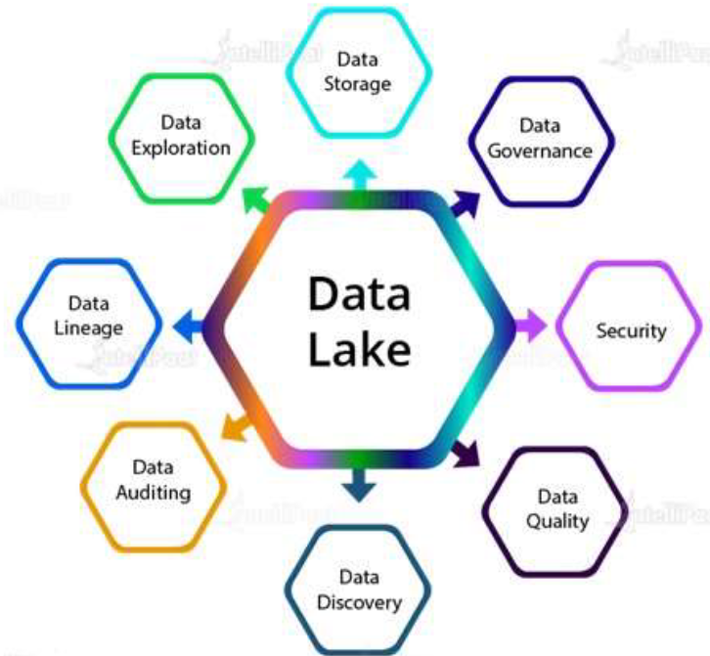

### DATA INGESTION

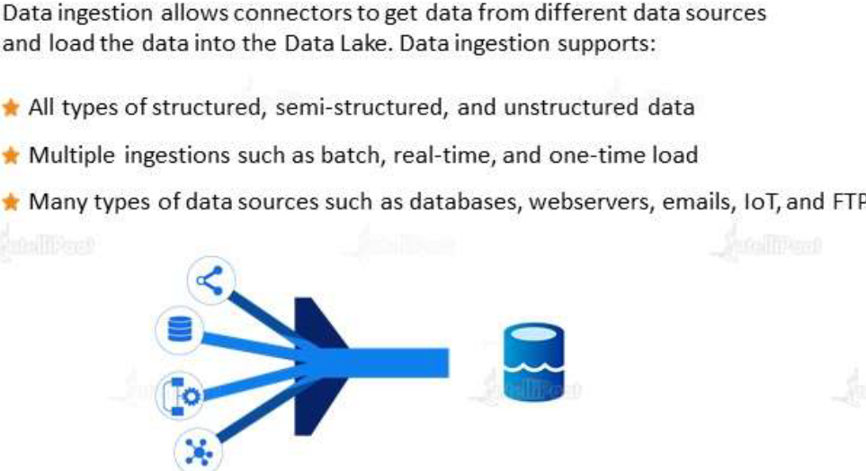

### DATA STORAGE

* Data storage is scalable and offers cost-effective storage . It allows faster access of data exploration and supports various data formats.

### DATA GOVERNANCE

* Data governance is the process of managing the availability , usability , security and integrity of use the data used in an organization

### SECURITY

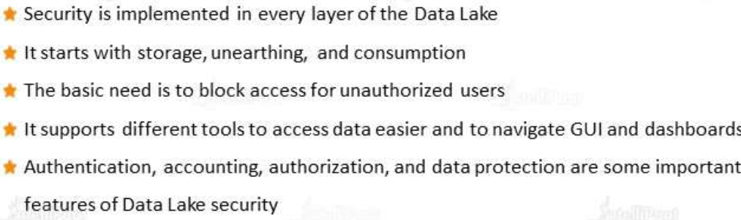

### DATA QUALITY

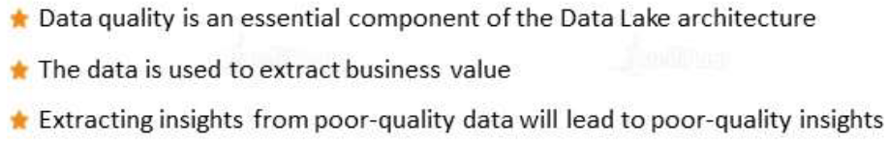

### DATA DISCOVERY

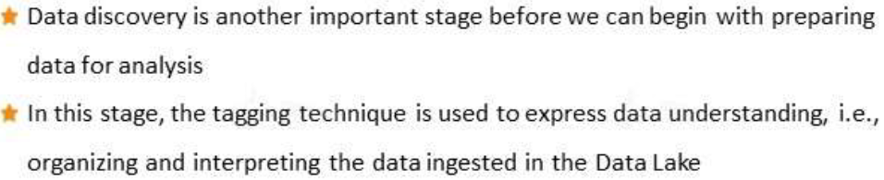

### DATA AUDITING

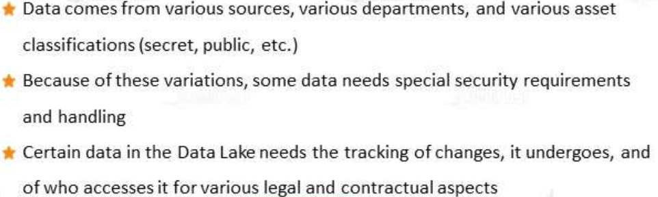

### DATA LINEAGE

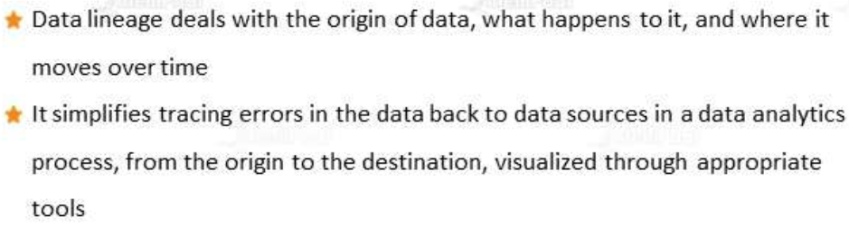

### DATA EXPLORATION

* Data exploration is beginning stage of data analysis
* This process enables deeper data analysis as patterns and trends are identified

|  |  |
| --- | --- |
| **DATA LAKE IN AZURE**  Data lakes - Azure Architecture Center | Microsoft Learn | * A data lake is a system or [repository of data](https://en.wikipedia.org/wiki/Data_repository) stored in its natural/raw format(images, text, JSON format), usually object [blobs](https://en.wikipedia.org/wiki/Binary_large_object) or files. * Data lake is used when we are working with large data sets and data is arriving in large volumes and at fast rate. * The data lake has been provided as PAAS in Azure using Azure data lake storage account. |

# AZURE DATA LAKE STORAGE ACCOUNT

* Azure Data Lake Gen2 storage accounts is a service that provides the option of hosting a data lake on Azure.
* Data lake account can be used when we are working with large data sets and data is arriving in large volumes and at fast rate.
* ***Data Lake Storage account is built on top of Azure Blob Storage. Here we make use of features of a hierarchical name space on top of Azure block storage itself. This hierarchy helps to organize the objects and the files into a hierarchy of directories for efficient data access.***
* Data lake is used to store large amount of data in its native, raw format. It is optimized for storing terabytes and petabytes of data

## CREATING DATA LAKE GEN-2 STORAGE ACCOUNT

|  |  |
| --- | --- |
|  | * The data lake storage account is created same as storage account -with a difference |

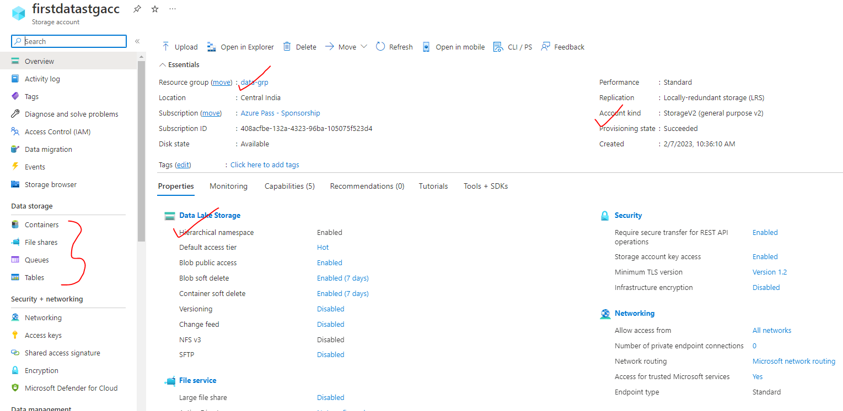

### CREATING CONTAINIER AND UPLOAD BLOB OBJECTS

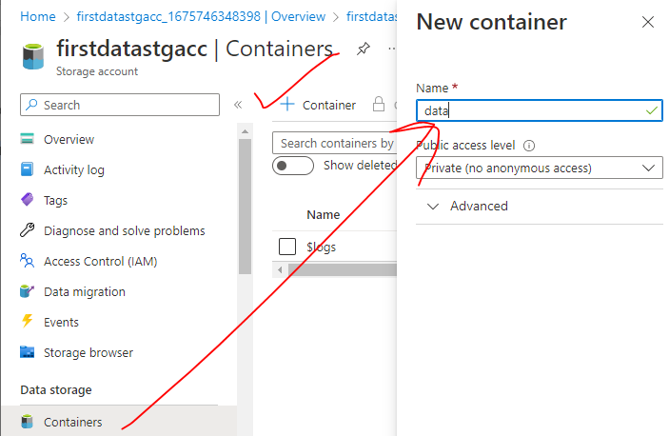

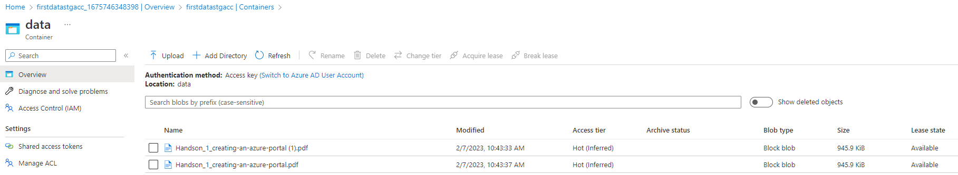

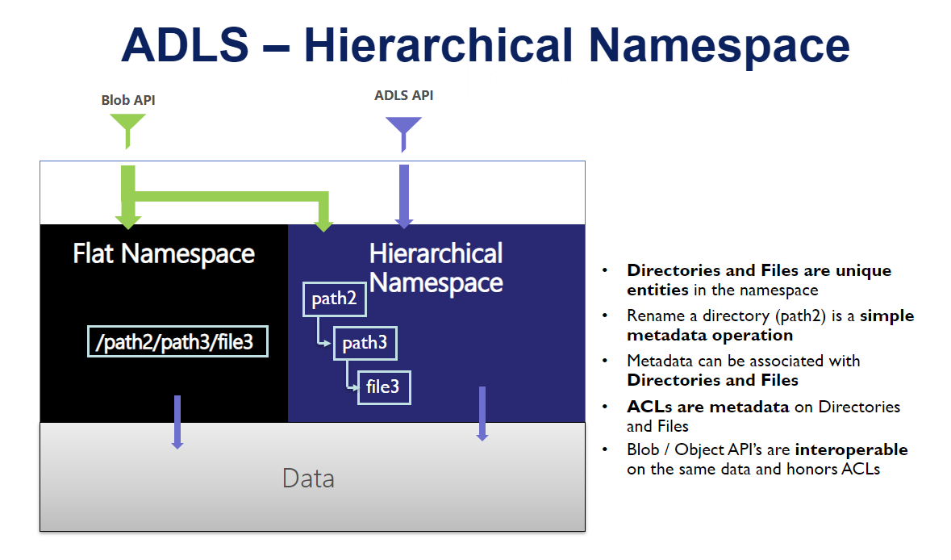

## CONNECTING STORAGE EXPLORER WITH DATA LAKE STORAGE ACCOUNT

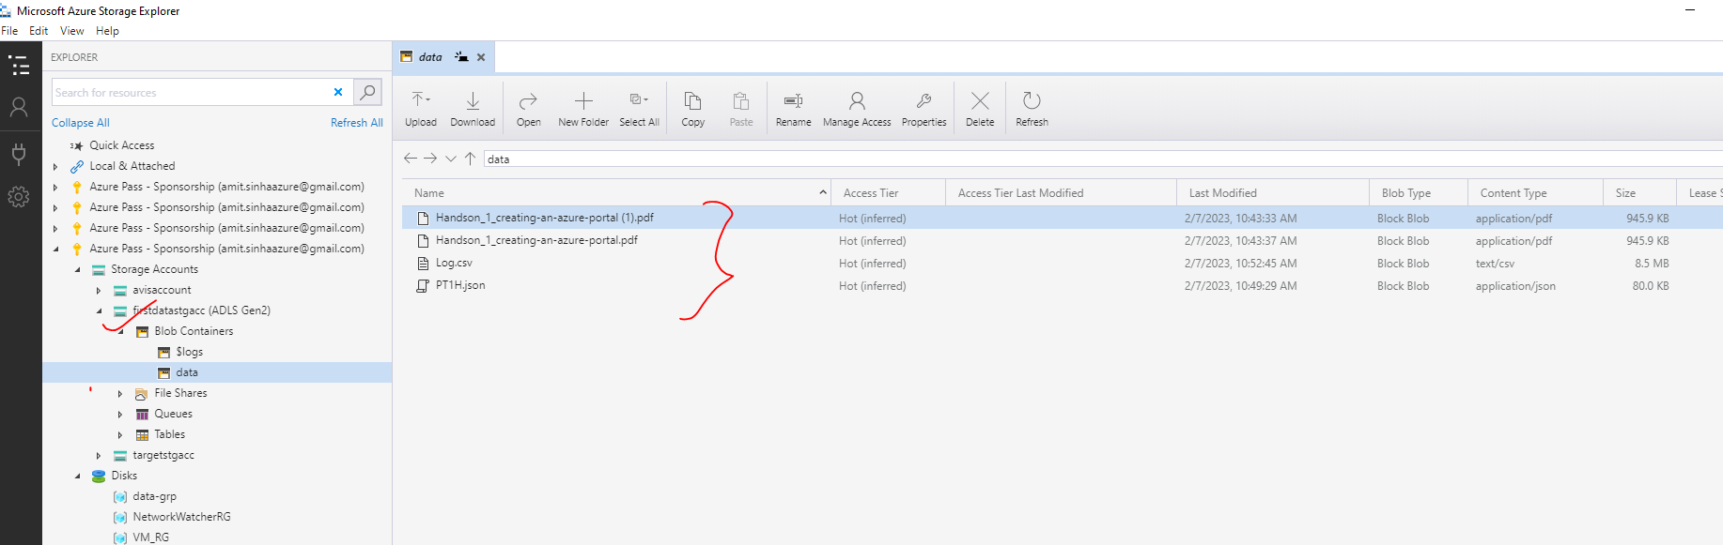

The data lake storage account can be connected to storage explorer- same as General Purpose Storage account. The different ways to connect are (refer the details in Azure Storage Account documentation)

1. **SUBSCRIPTION**
2. **ACCESS KEYS**
3. **SHARED ACCESS SIGNATURE**

# RELATIONAL DATABASE IN AZURE

## ACID PROPERTY OF RELATIONAL DATABASE

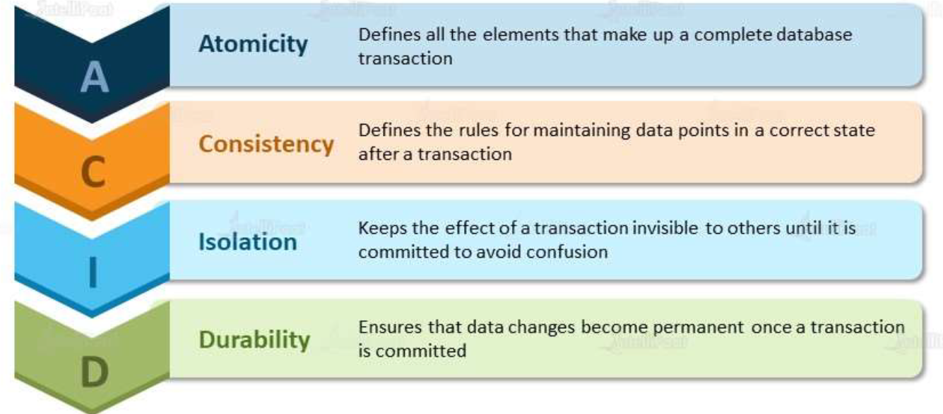

### EXAMPLES

|  |  |
| --- | --- |
| ATOMICITY | * This make sure if a transaction is happening – it should happen at once and if it fails the entire transaction without any data corruption. |
| ISOLOATION | * All the transaction has to Independent of each other . No other transaction block the other one. |

## AZURE OFFERING FOR RELATIONAL DATABASE(PAAS)

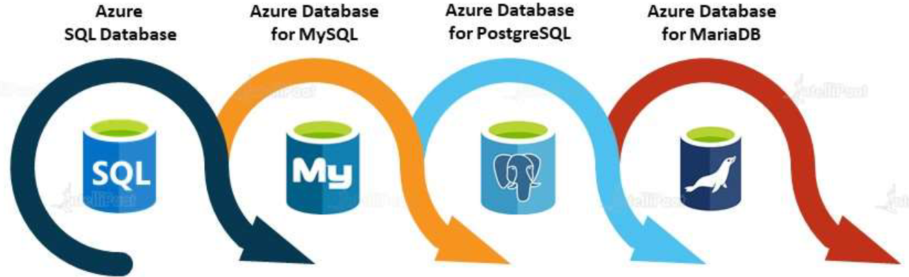

## AZURE SQL DATABASE

* Azure SQL database is general purpose relational database, provided as managed service (PAAS). Since it’s a manages service – we will be always on latest Microsoft SQL server data engine.
* With Azure SQL database we can make use of advanced query processing features like
  + HIGH PERFORMANCE IN MEMORY TECHNOLOGIES
  + INTELLIGENT QUERY PROCESSING

### DEPLOYMENT MODEL OF SQL DATABASE

When we are provisioning Azure SQL database – then the azure SQL database comes in 3 flavors(deployments options)

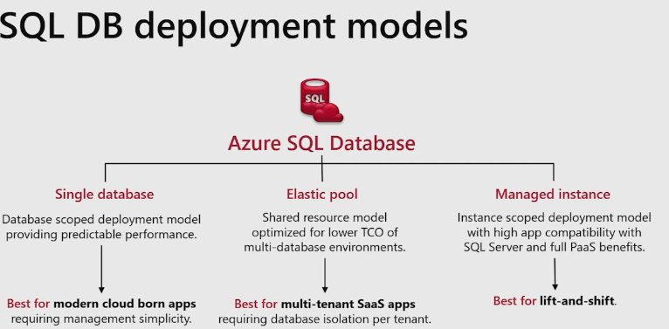

#### SINGLE DATABASE

* In on-premises environment to set a database- we first create a DB server (ex- SQL database server) and then create DB in the server.
* But in case of Azure Single database – the DB server is managed by Azure itself. These servers are basically logical server. We can go ahead and create DB in the Azure managed DB servers.
* Single database represents fully managed isolated database
* We can use this option if we have cloud applications and microservices that need single reliable data source.

#### MANAGED INSTANCE

#### ELASTIC POOL

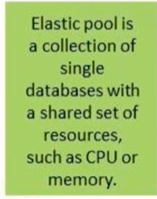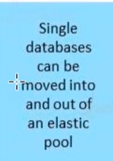

### CREATING SQL DATABASE

To create SQL database server - Select SQL database service 🡪 Create SQL Database.

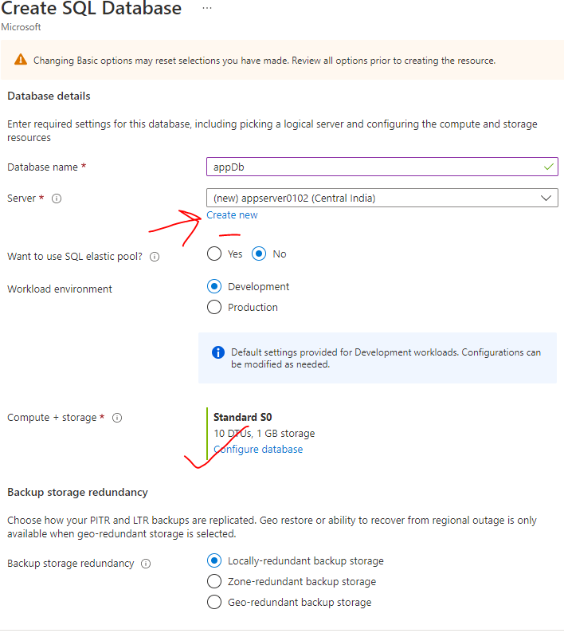

### CONFIGURING THE DATABASE

SQL database enable us to easily define and scale the performance within 2 -purchasing models

* **DTU BASED PURCHASE MODEL**
* **VCORE-BASED PURCHASING MODEL**

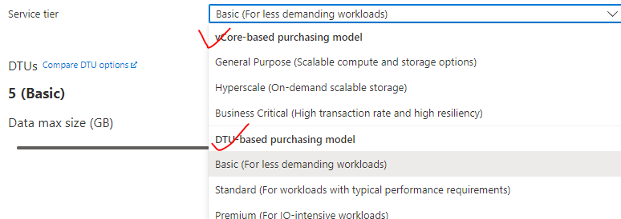

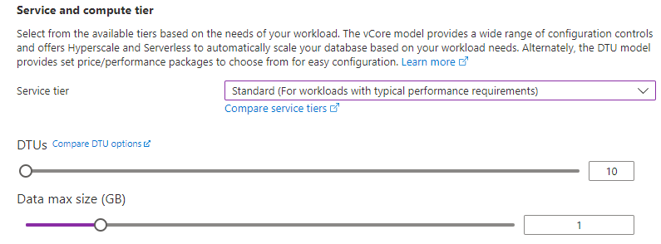

### NETWORKING

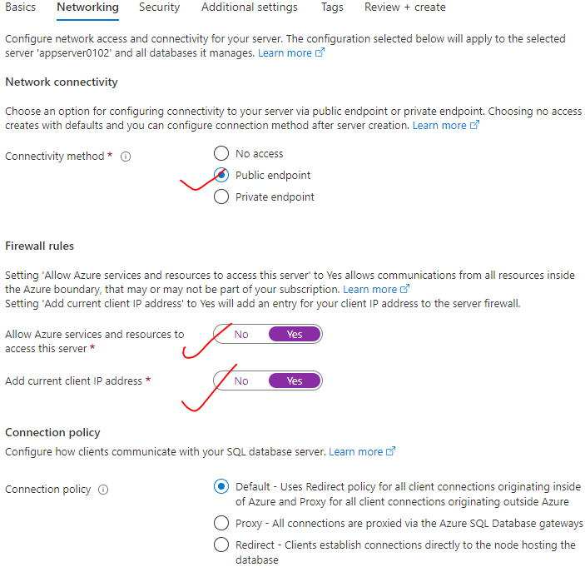

### ADDITIONAL SETTINGS

* We can make use of sample data as well. This will pre-populate the DB with tables with sample data

|  |  |
| --- | --- |
|  |  |

* Note - This implementation creates two resources.

1. **AZURE SQL DATABASE SERVER**
2. **AZURE SQL DATABASE.**

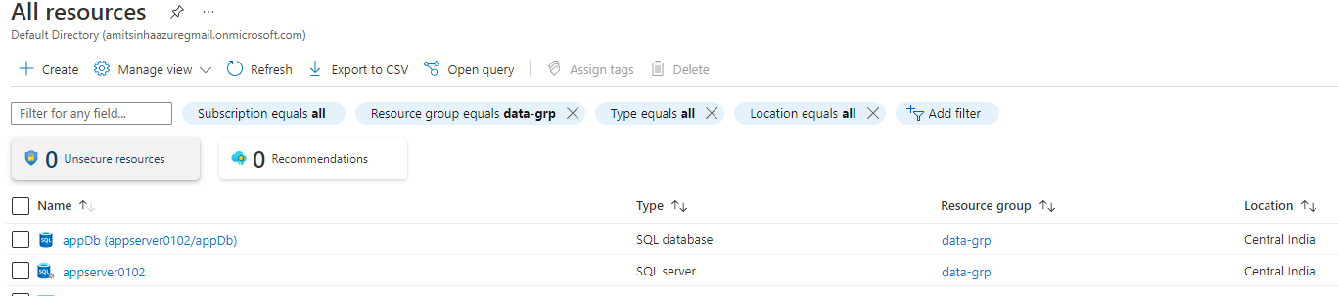

* **We can have one DB server with multiple SQL data base.**

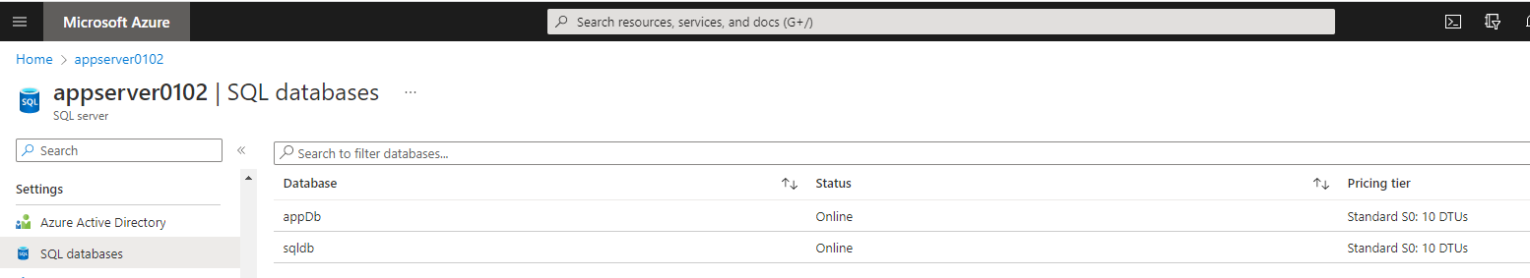

### ELASTIC POOL IN SQL DATABASE

### CONFIGURING SQL SERVER STUDIO

* To connect the SQL server studio with SQL Database server and hence access the SQL DB

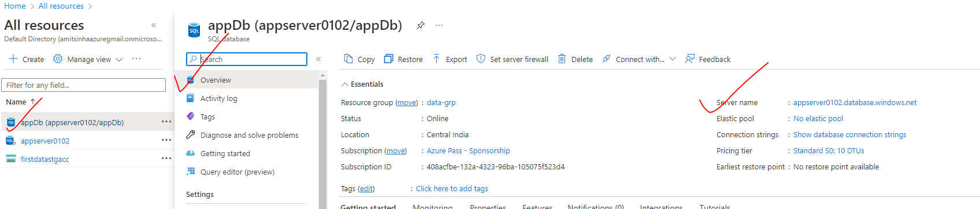

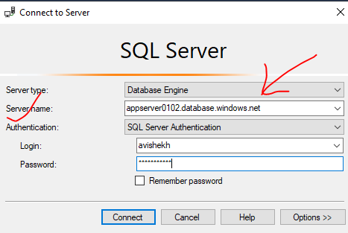

### USE CASE (BATCH OPERATION)

* Let’s say we have a customer database having orders table. We want to process the data incrementally using ADF to the orders table of “demobits” DB
* We are maintaining on more “watermarking” table which maintains the timestamp of last process data in orders table.

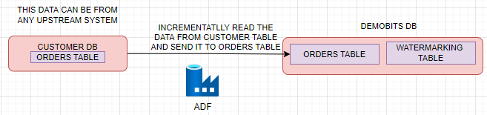

|  |  |
| --- | --- |
| CREATE TABLE | INSERTING DATA |
| CREATE TABLE ORDERS (      ORDERID int,      PRODUCTID int,      CUSTOMERID int,      UNIT_PRICE varchar(255),      QUANTITY int,      INSERT_TIME_STAMP datetime)  CREATE TABLE WATER_MARK_TABLE (  TABLE_NAME varchar(50),  WATER_MARK_VALUE datetime) | INSERT INTO [dbo].[ORDERS] VALUES(1,1001,2001,'204',50,'2023-02-12 16:01:38.567')  INSERT INTO [dbo].[ORDERS] VALUES(2,1002,2002,'344',60,'2023-02-13 16:01:38.567')  INSERT INTO [dbo].[ORDERS] VALUES(3,1003,2003,'34',70,'2023-02-14 16:01:38.567')  INSERT INTO [dbo].[ORDERS] VALUES(4,1004,2004,'789',690,'2023-02-15 16:01:38.567')  INSERT INTO [dbo].[ORDERS] VALUES(5,1005,2005,'239',666,'2023-02-16 16:01:38.567')  INSERT INTO [dbo].[ORDERS] VALUES(6,1006,2006,'394',770,'2023-02-17 16:01:38.567') |

**ORDERS TABLE**

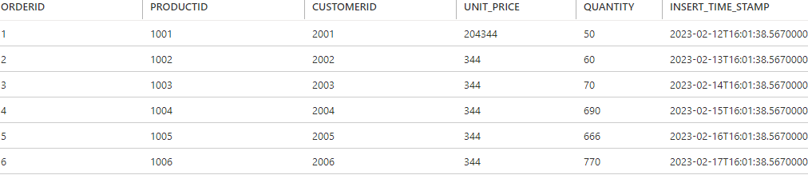

WATERMARKING TABLE

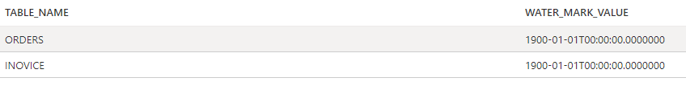

1. STEP 1: Create a Linked Service for customerDB
2. STEP 2: Create a Linked Service for demobitsDB

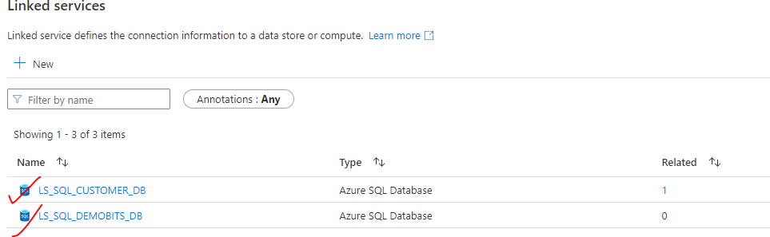

|  |  |
| --- | --- |
|  | 1. STEP 3: Create Dataset for source table(orders table in customer DB) 2. STEP 4: Create data set for target table (orders table in customer DB) 3. STEP 5: Create dataset for water_marking table |

1. **STEP 6: Create a Pipeline**

|  |  |
| --- | --- |
|  | * We will first do a look up in the watermark table to find from which time stamp we need to read the data (WATER_MARK_VALUE) * Look up in the orders table to check the latest “INSERT_TIME_STAMP” * These 2 timestamps will give us a range of timestamp till when we must select the data to process. * Finally – the stored procedure will update the “WaterMarking” table with the latest “INSERT_TIME_STAMP” in orders table. |

1. Drag and drop the **look up activity**

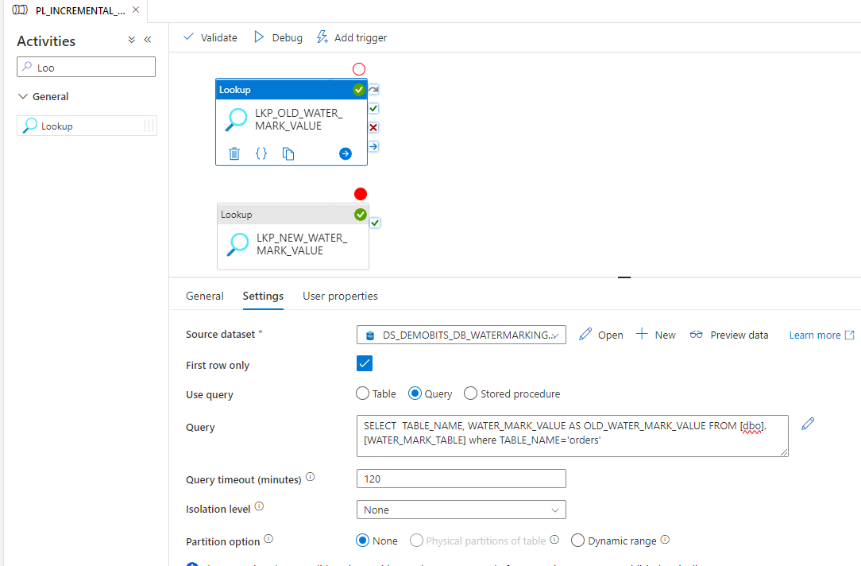

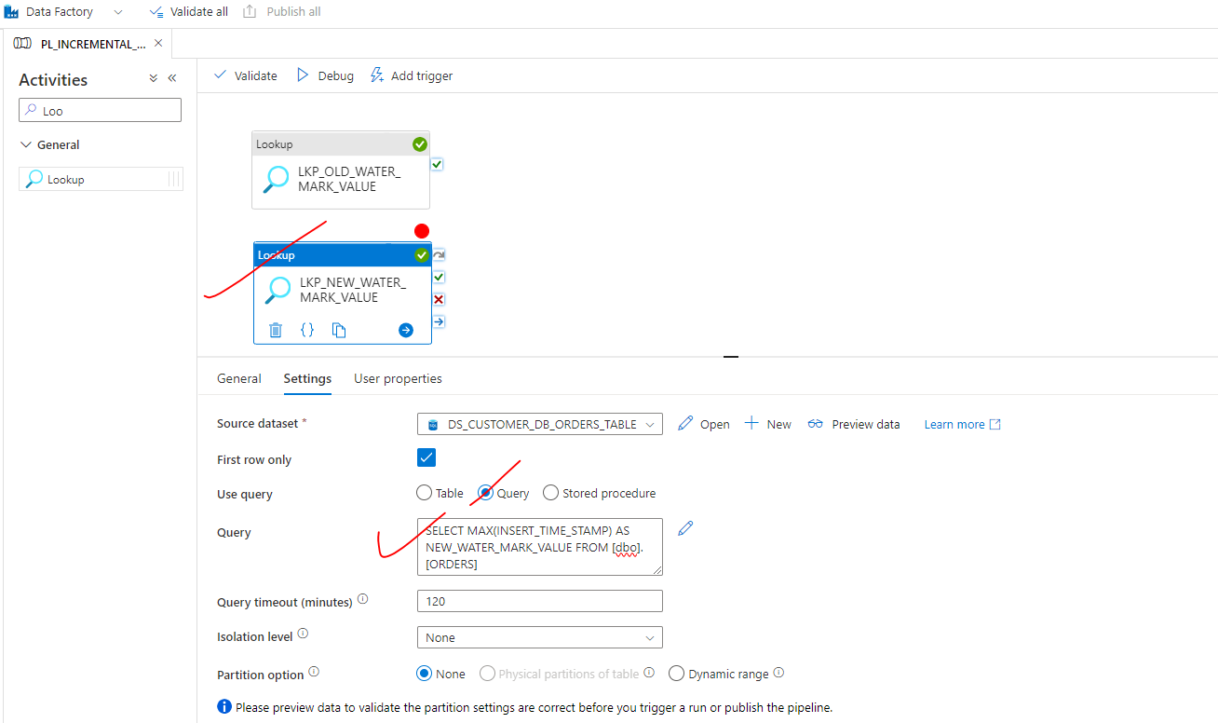

|  |  |
| --- | --- |
|  |  |
| * Publish All and Debug * After the debug is successful – Monitor the output of each look up activity. The output of this will be used in the next activity (copy data activity) * The above timestamp range will help copy data activity to select the data with a given timestamp range | |

**STEP 7: Add a Copy data activity**

* The copy data activity will copy the data from orders table of customer DB (source DB) to order table of target DB
* The output from previous activity becomes the input for copy data activity

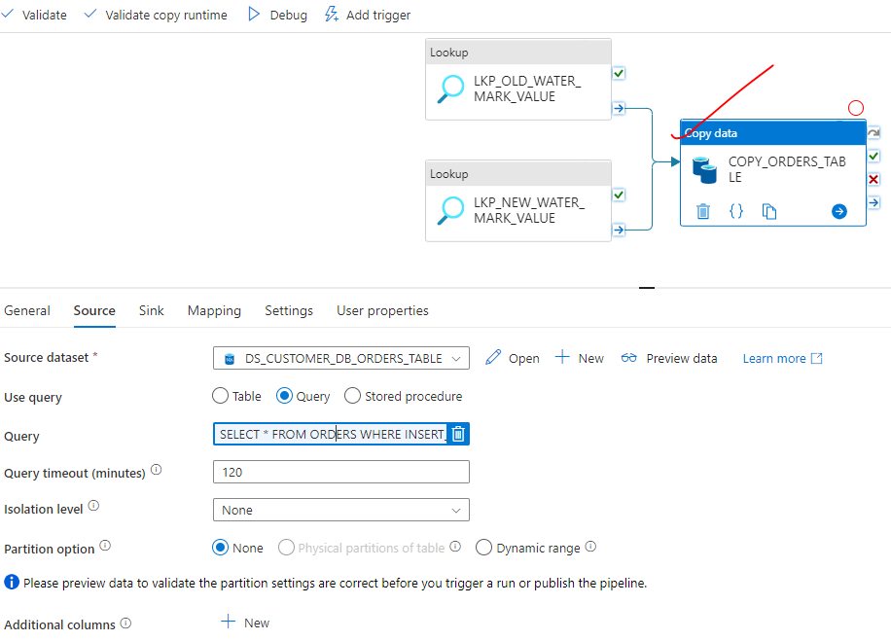

***The query is written as an expression. The expressions are evaluated based the output of previous activity.***

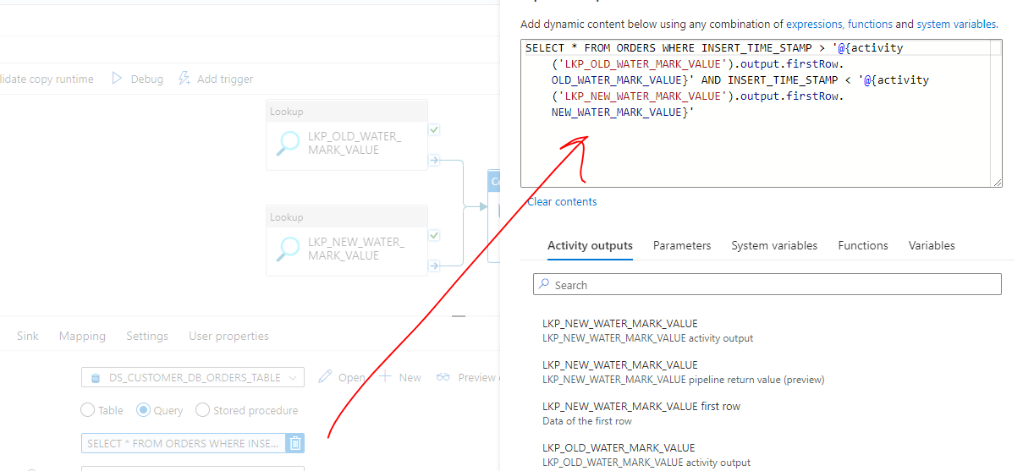

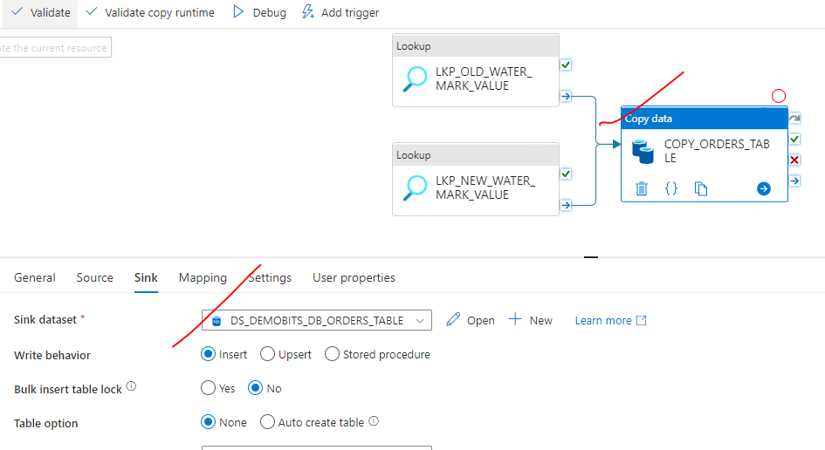

**MAP THE SOURCE AND TARGET TABLE**

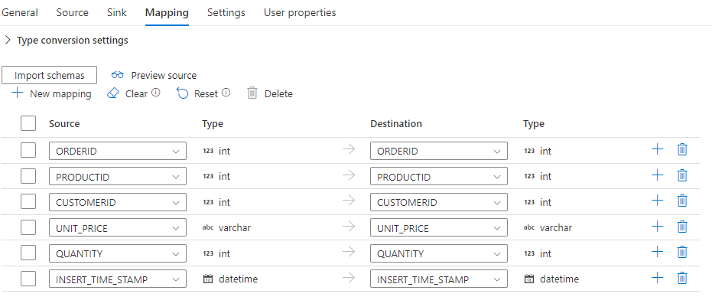

Step 8 : Add the Stored Procedure Activity

|  |  |
| --- | --- |
| CREATE PROCEDURE SP_SET_WATERMARK      @TableName varchar(50),      @NewDataTime datetime  AS  BEGIN      UPDATE [dbo].[WATER_MARK_TABLE]      SET [WATER_MARK_VALUE] = @NewDataTime      WHERE [TABLE_NAME] =@TableName      END; | * The Stored procedure has 2 input parameters. * These parameters will be passed dynamically |
|  | |

PASSING THE PARAMETER TO STORED PROCEDURE

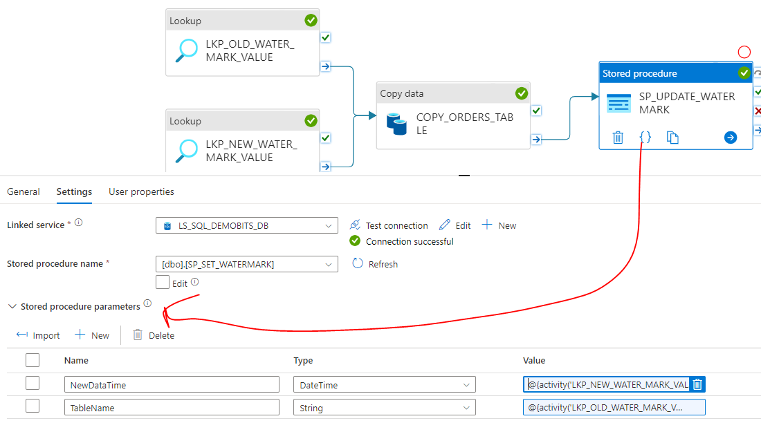

* Dynamic Parameter - @{activity('LKP_NEW_WATER_MARK_VALUE').output.firstRow.NEW_WATER_MARK_VALUE}

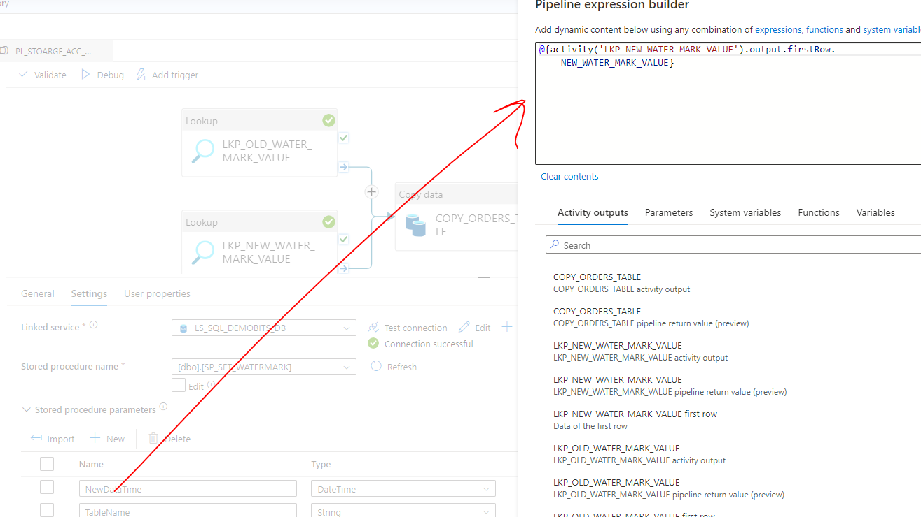

* Dynamic Parameter Value : @{activity('LKP_OLD_WATER_MARK_VALUE').output.firstRow.TABLE_NAME}

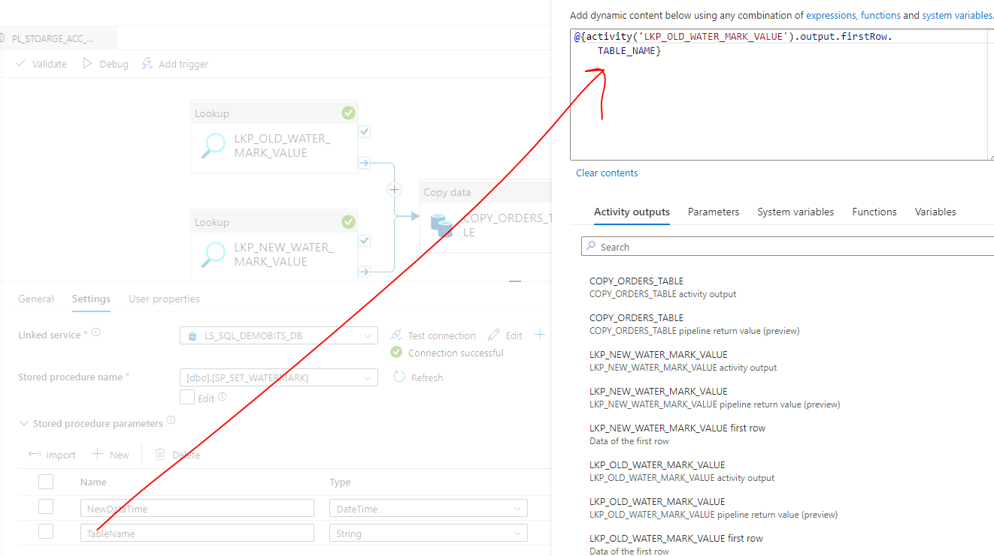

### PARAMETERIZING THE PIPELINE

* In the above example – the table name, DB names, column name are hardcoded. From reusability standpoint – we can parameterize the pipeline to accept input at runtime.
* In the below example – Lets parameterize the target table name to which we want to copy the data

**STEP 1: ADD A PARAMETER TO PIPELINE**

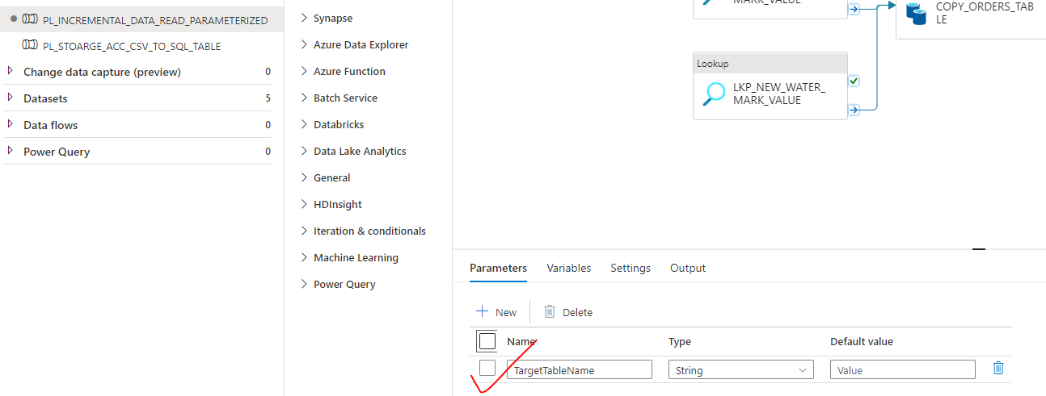

**STEP 2: USE THE PIPELINE PARAMETER IN THE ACTIVITY (DYNAMICALLY)**

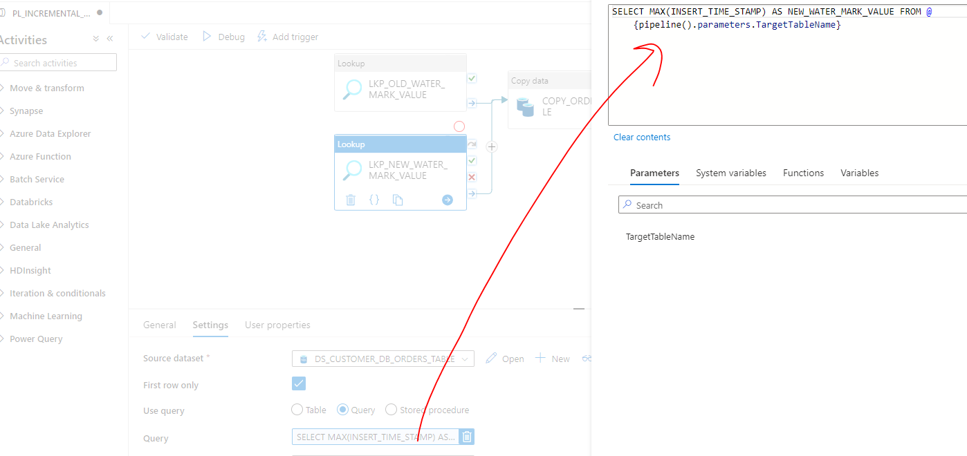

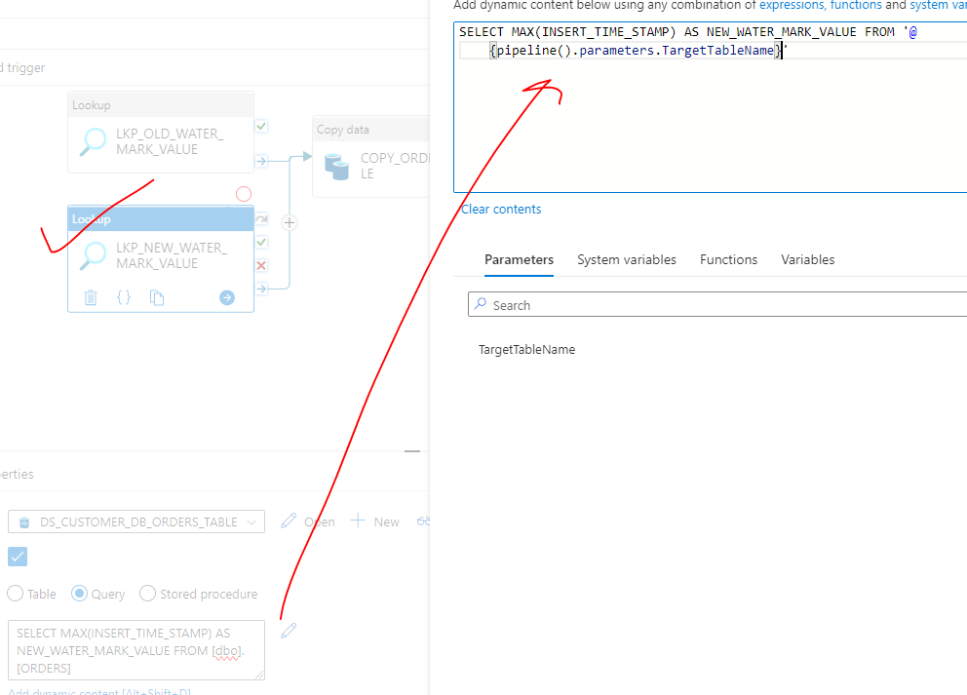

**PARAMETIZING THE TARGET TABLE IN COPY DATA ACTIVITY**

1. **DATASET**

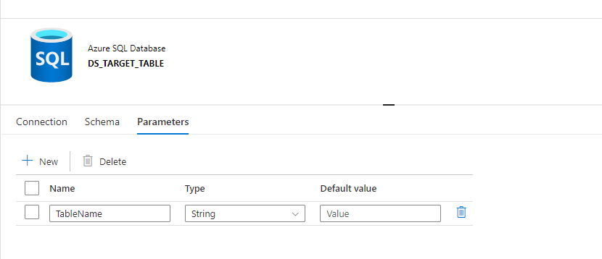

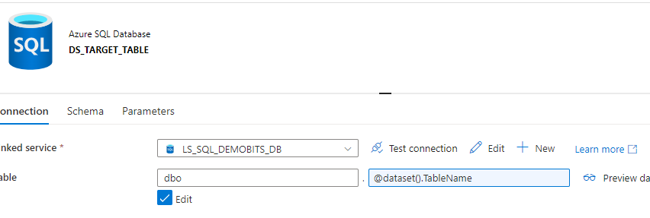

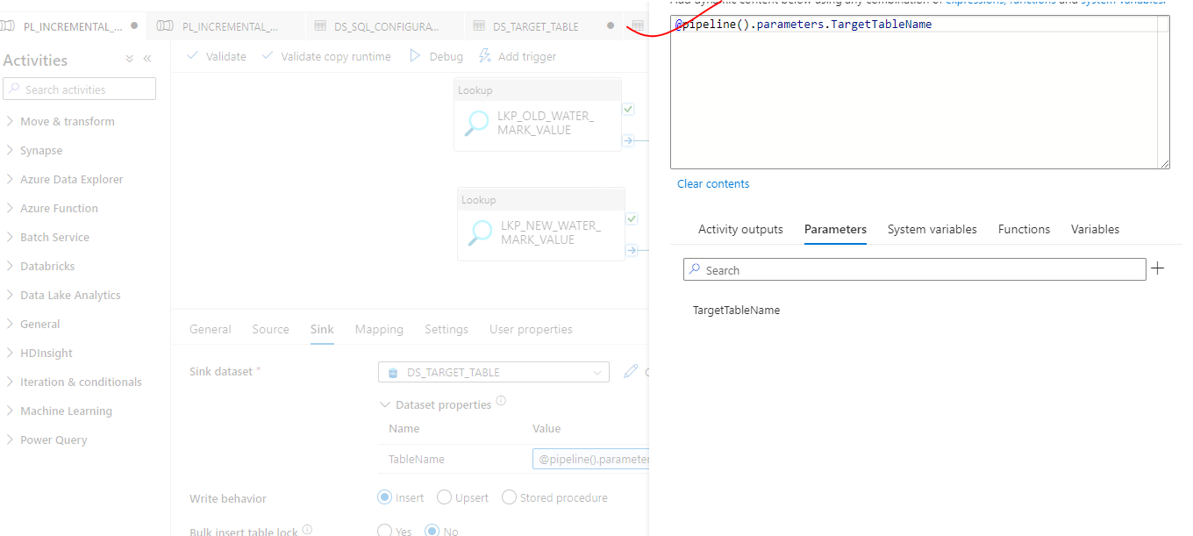

**PASSING VALUE WHILE PIPELINE EXECUTION**

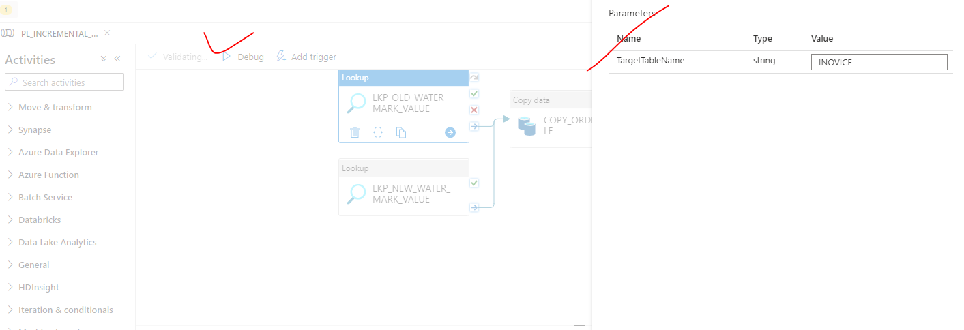

In the above example – We need to pass the parameters to the pipeline. To automate the process, we can follow the following process

|  |  |
| --- | --- |
| **CREATE CONFIGURATION TABLE WHICH WILL HAVE TABLE NAME**  This table name in the Configuration table will be pass as parameter to the pipeline as input parameter. |  |

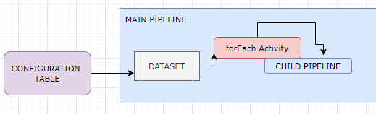

|  |  |
| --- | --- |
| **The configuration table will feed the data “forEach“activity of Main Pipe line . Each item in forEach iteration will passed to child pipeline.**   1. CREATE THE MAIN PIPELINE 2. DRAG AND DROP THE LOOKUP ACTIVITY 3. CREATE A DATASET (INPUT) FOR CONFIGURATION TABLE |  |
|  | CONFIGURE DATASET |

SETTING UP FOREACH ACTIVITY

* Drag and drop the forEach activity. The output of Look up activity (value property) will be feed into forEach activity.

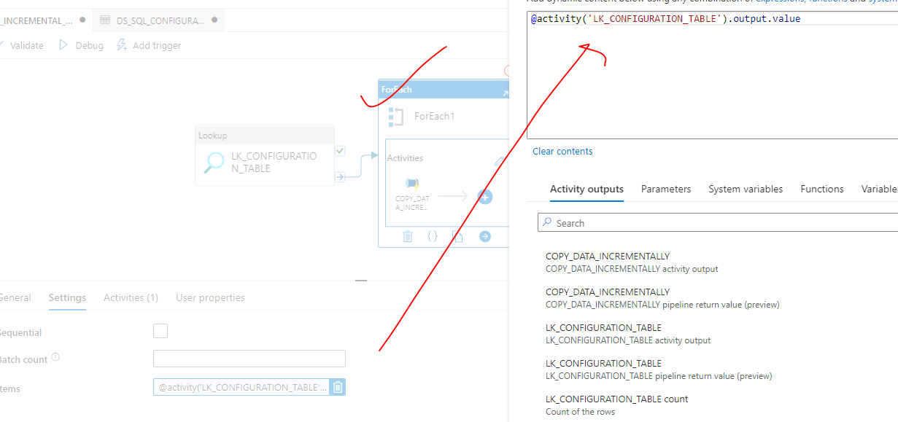

* Since we need to execute a child pipeline in the forEach activity 🡪 Drag and drop the “Execute Pipeline” activity

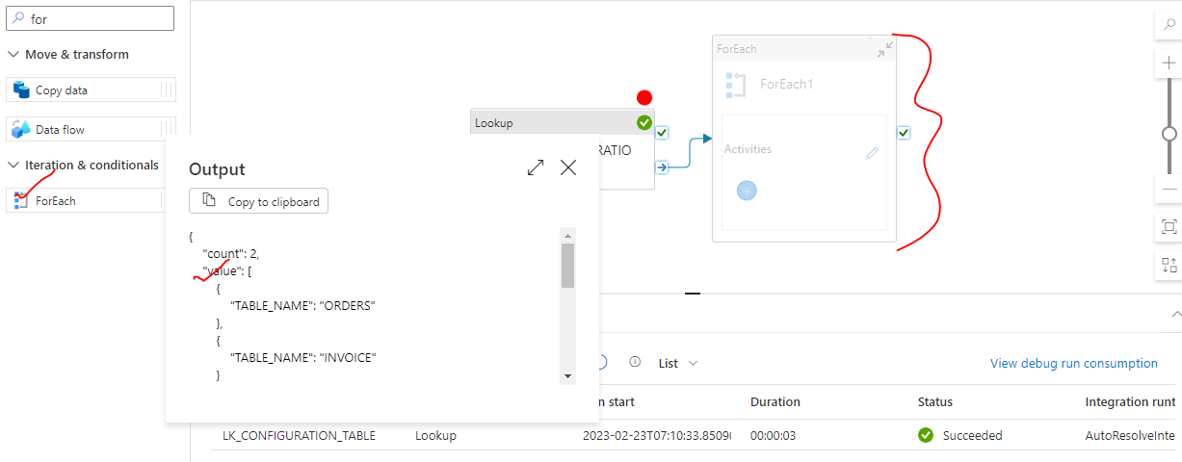

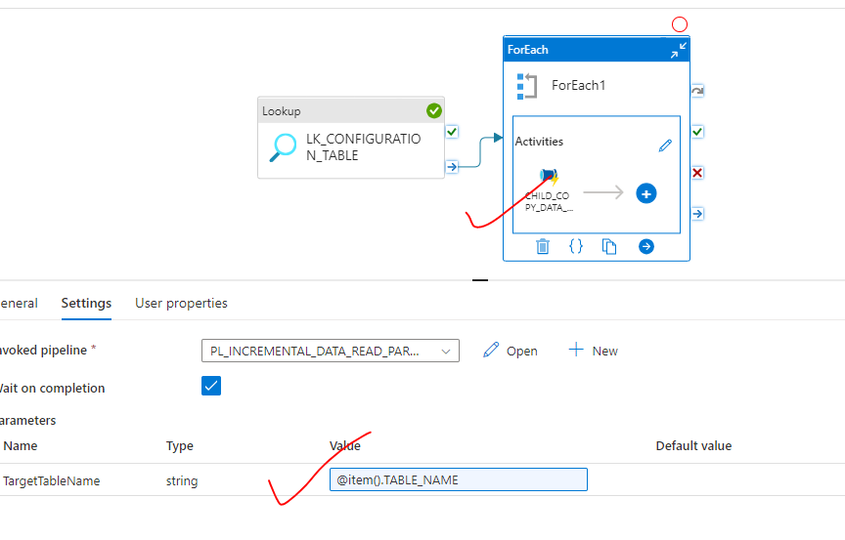

# ETL(EXTRACT-TRANSFORM-LOAD)

|  |  |
| --- | --- |
| What is ETL? (Extract Transform Load) | Informatica | ETL is a process of extracting data from a variety of data sources and load the data into a target area. Example -extracting data from an Azure SQL Database or SQL server instance hosted in an on-premise environment and load it on to an Azure SQL Data Warehouse after perform some sort of transformation of the data |

# AZURE SYNAPSE ANALYTICS

# AZURE DATA FACTORY

|  |  |
| --- | --- |
|  | As the data comes from multiple sources but to analyze and store all this data – Azure data factory help us in following ways   1. *Storing data with the help of Data Lake storage* 2. *Analyzing the data* 3. *Transforming the data with help of pipelines* 4. *Publishing the organized data* 5. *Visualizing the data with third party application like Apache Spark / Hadoop* |

## WHAT PROBLEM DOES IT SOLVE?

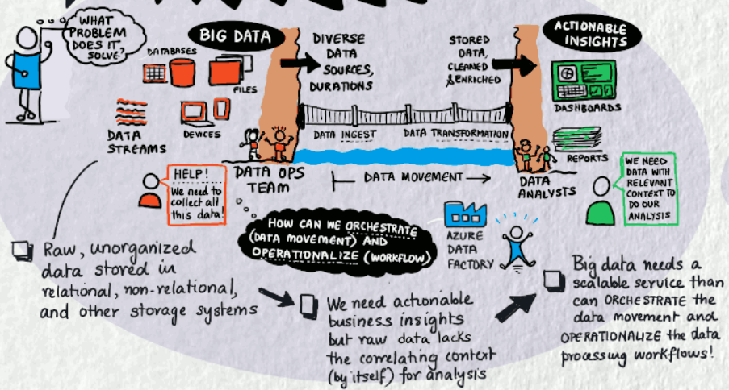

## USAGE SCENARIOS

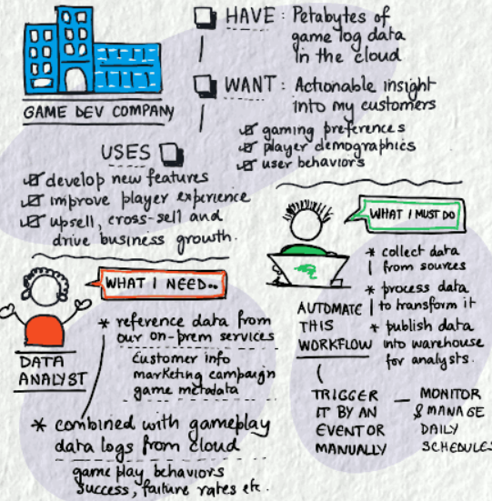

* For example, imagine a gaming company that collects petabytes of game logs that are produced by games in the cloud. The company wants to analyze these logs to gain insights into customer preferences, demographics, and usage behavior. It also wants to identify up-sell and cross-sell opportunities, develop compelling new features, drive business growth, and provide a better experience to its customers.
* To analyze these logs, the company needs to use reference data such as customer information, game information, and marketing campaign information that is in an on-premises data store. The company wants to utilize this data from the on-premises data store, combining it with additional log data that it has in a cloud data store.
* To extract insights, it hopes to process the joined data by using a Spark cluster in the cloud (Azure HDInsight), and publish the transformed data into a cloud data warehouse such as Azure Synapse Analytics to easily build a report on top of it. They want to automate this workflow and monitor and manage it on a daily schedule. They also want to execute it when files land in a blob store container.
* Azure Data Factory is the platform that solves such data scenarios. **It is the cloud-based ETL and data integration service that allows you to create data-driven workflows for orchestrating data movement and transforming data at scale**.
* Using Azure Data Factory, we can create and schedule data-driven workflows (called pipelines) that can ingest data from disparate data stores. We can build complex ETL processes that transform data visually with data flows or by using compute services such as Azure HDInsight Hadoop, Azure Databricks, and Azure SQL Database.
* Additionally, we can publish your transformed data to data stores such as Azure Synapse Analytics for business intelligence (BI) applications to consume. **Ultimately, through Azure Data Factory, raw data can be organized into meaningful data stores and data lakes for better business decisions**.

## COMPONENTS OF AZURE DATA FACTORY

**PROCESS FLOW**

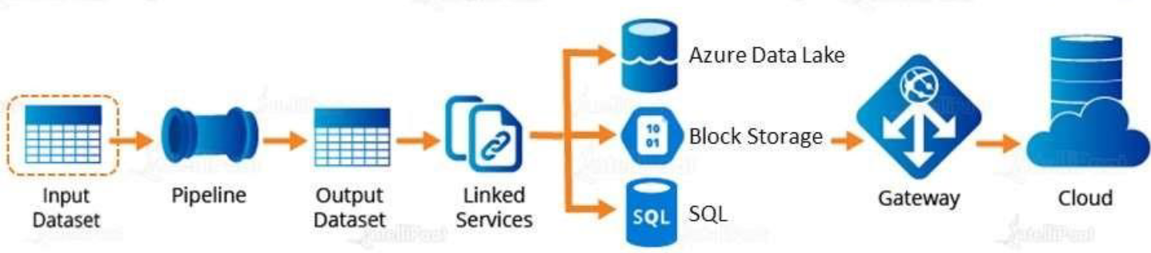

### PIPELINE

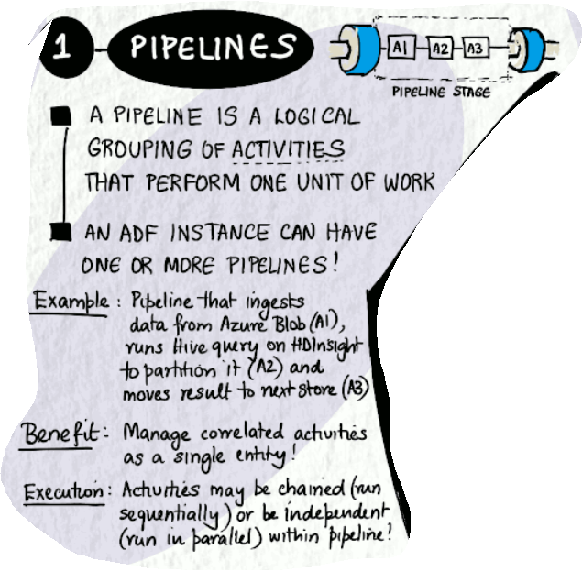

### ACTIVITIES

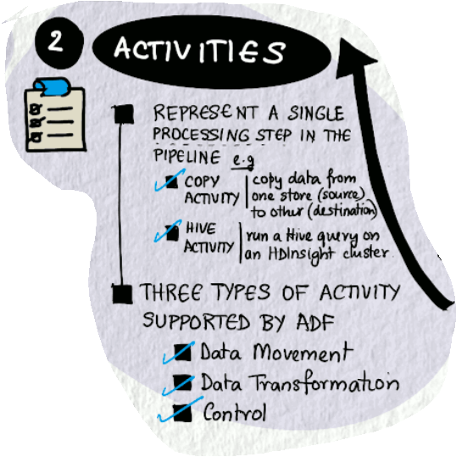

### DATASET

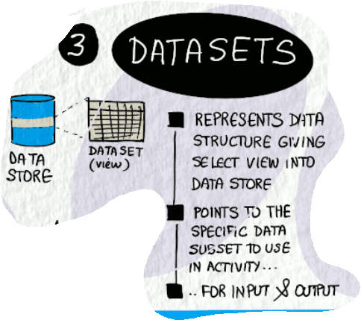

### LINKED SERVICE

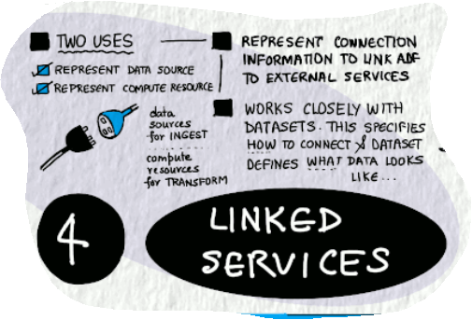

### MAPPING DATA FLOWS

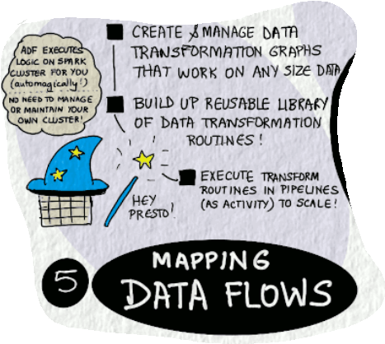

### INTEGRATION RUNTIMES

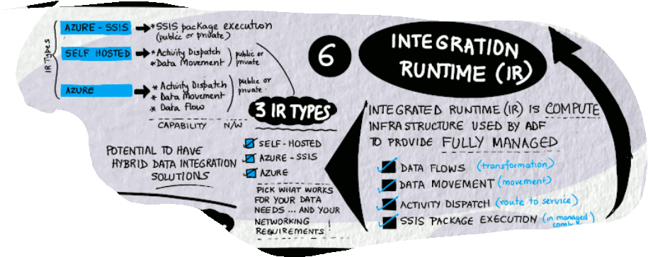

* A default Integration runtime is created while provisioning the ADF. This gives the compute power to the ADF
* This runtime help us to connect to any PASS withing Azure ecosystem (e.g Storage Account , Azure SQl DB etc..)
* Other than pass PASS resources (like VM in Azure) we need to create a new IR

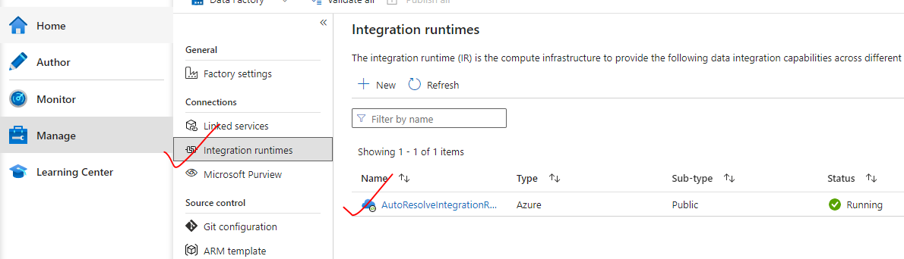

**CREATING A NEW IR**

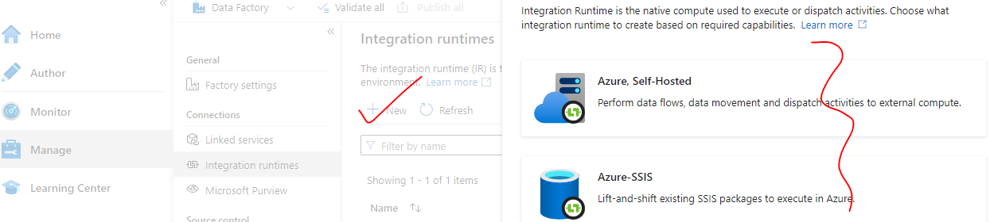

***These components work together to provide the platform on which you can compose data-driven workflows with steps to move and transform data.***

### ADDITIONAL CONCEPTS

1. **CONTROL FLOW**
2. **PIPELINE RUN**
3. **TRIGGERS**
4. **PARAMETERS**
5. **VARIABLES**

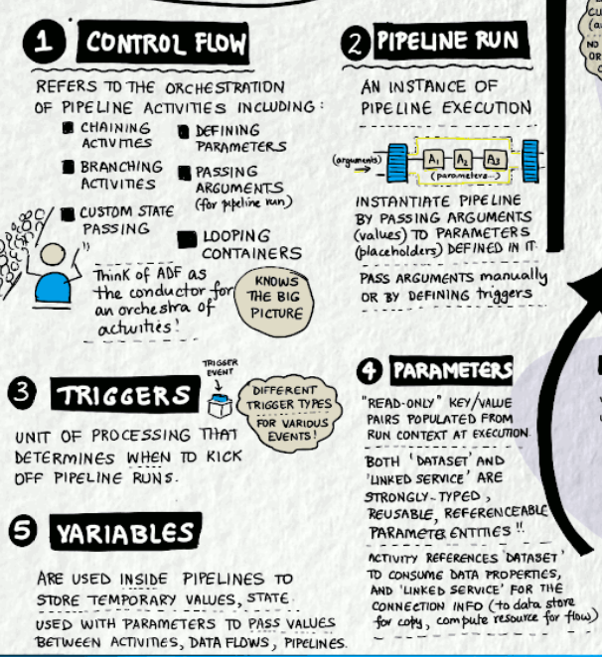

## SETTING UP AZURE DATA FACTORY

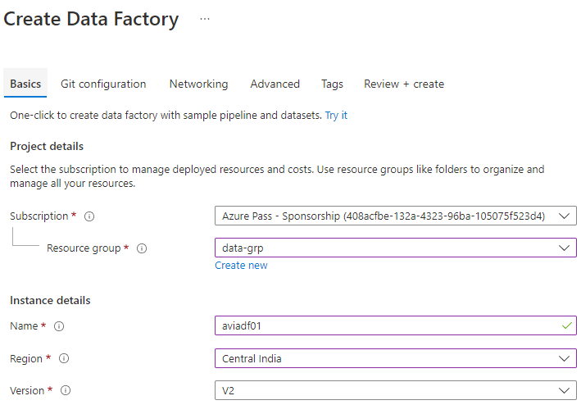

### ADF OVERVIEW

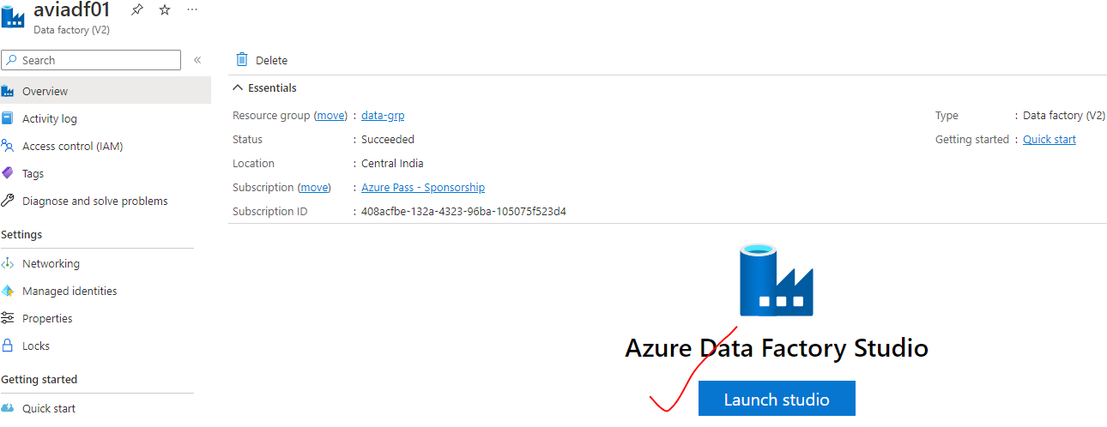

### ADF STUDIO

Azure Data factory Studio in web-based development IDE

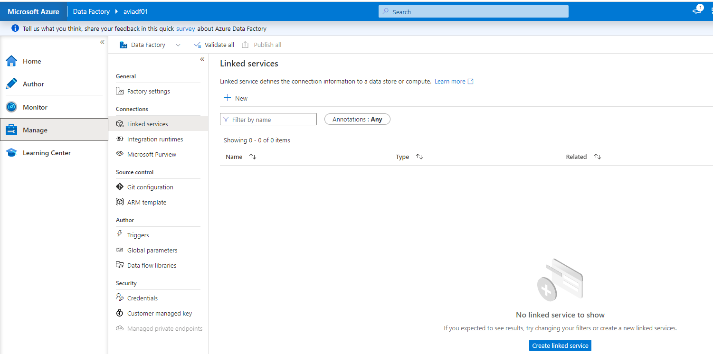

### SETTING UP ADF COMPONENTS

* To illustrate the ADF flow process – lets create demonstrate a use case
* **USE CASE – We will copy a file(e.g. JSON File) from source container to target container in storage account using ADF**

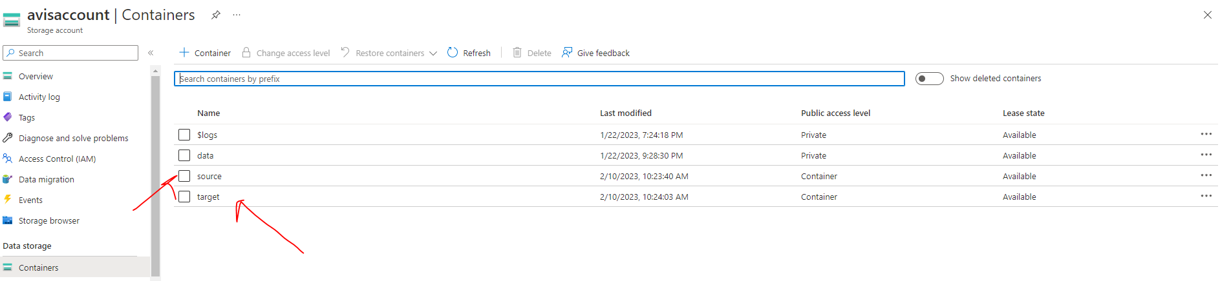

#### STEP 1: SET UP A LINKED SERVICE

* The linked service helps us to link ADF with external service (here its Storage Account)

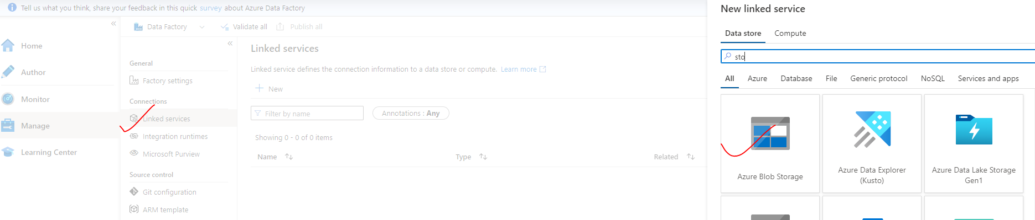

|  |  |
| --- | --- |
|  | * Note – ADF will have an Integration runtime created by default. This compute resource help as connect with any Azure PASS * For connection with on-prem external service we need to create a new IR. * While creating the Linked Service 🡪 Test Connection 🡪 Create |

#### STEP 2: SET UP DATASET

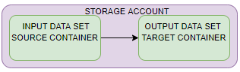

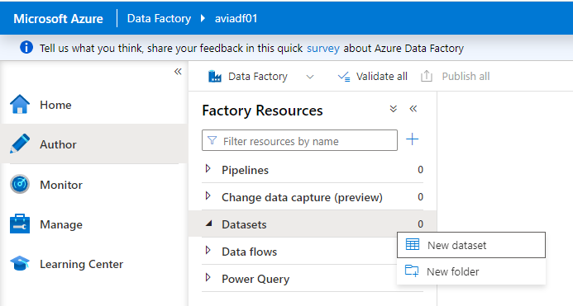

1. SET UP INPUT DATASET

|  |  |  |
| --- | --- | --- |
|  |  | Select the Storage Type for the Blob Storage and file format |
| SET UP THE PROPERTY   * Browse the path of the file from the “File path” field. | | |

1. SET UP OUTPUT DATASET

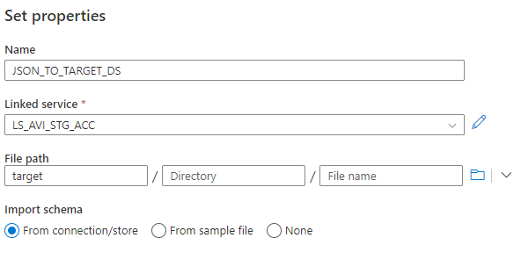

1. PUBLISH THE DATA SET

* If the dataset is not published – it will be lost if browser is refreshed.

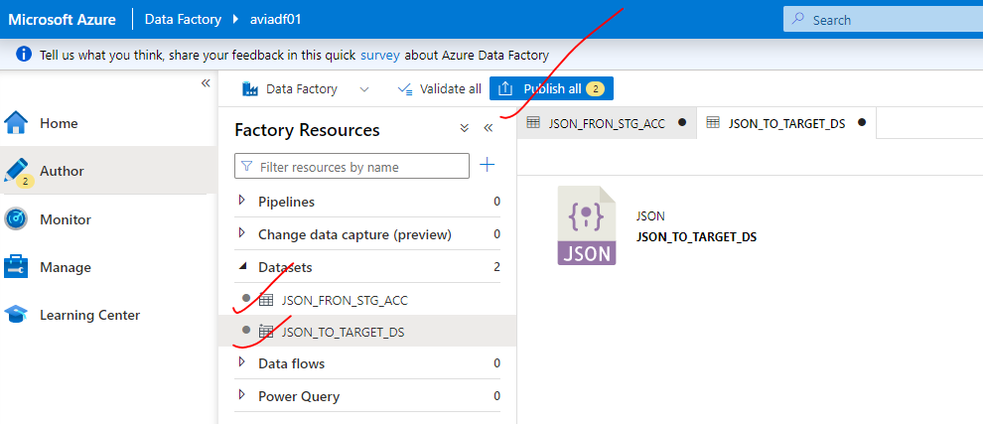

#### STEP 3: SET UP A PIPELINE

* Pipeline consists of activities . Here to for the copy the file – we will drag and drop the copy activity in the pipeline

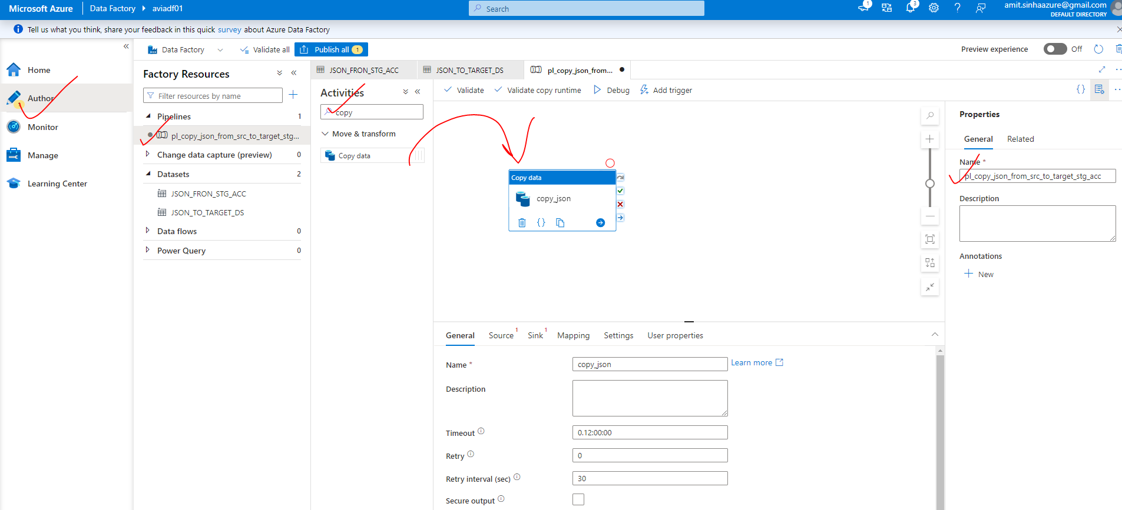

The activity is consisting of many properties

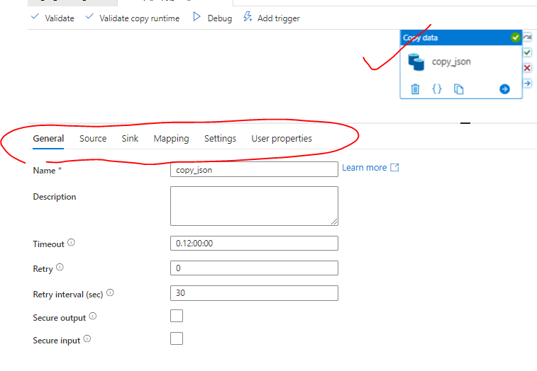

|  |  |
| --- | --- |
| Name | Name of the activity |
| Timeout | The time after which the activity will be timed out |
| Retry | Number of retries |
| Retry Interval | Interval after which next retry will happen |
| Secure output/input |  |

* SELECT THE SOURCE DATA SET

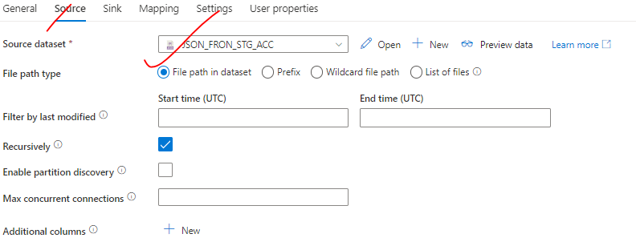

* SELECT THE TARGET DATA SET

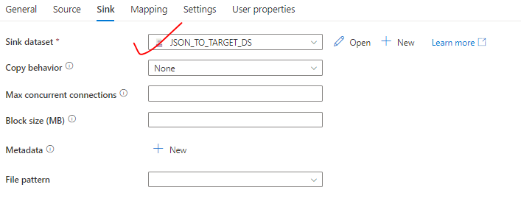

* PUBLISH THE PIPELINE

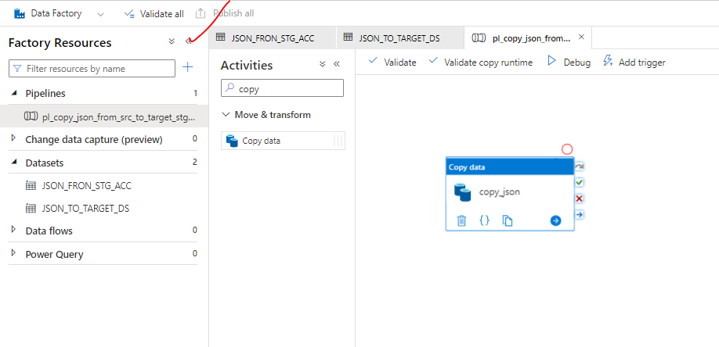

* RUNNING THE PIPELINE
* In real time – We set up triggers to trigger the pipeline. But we can run the pipeline with debug mode for testing.
* This will copy the JSON file from source container to target container in the storage account.

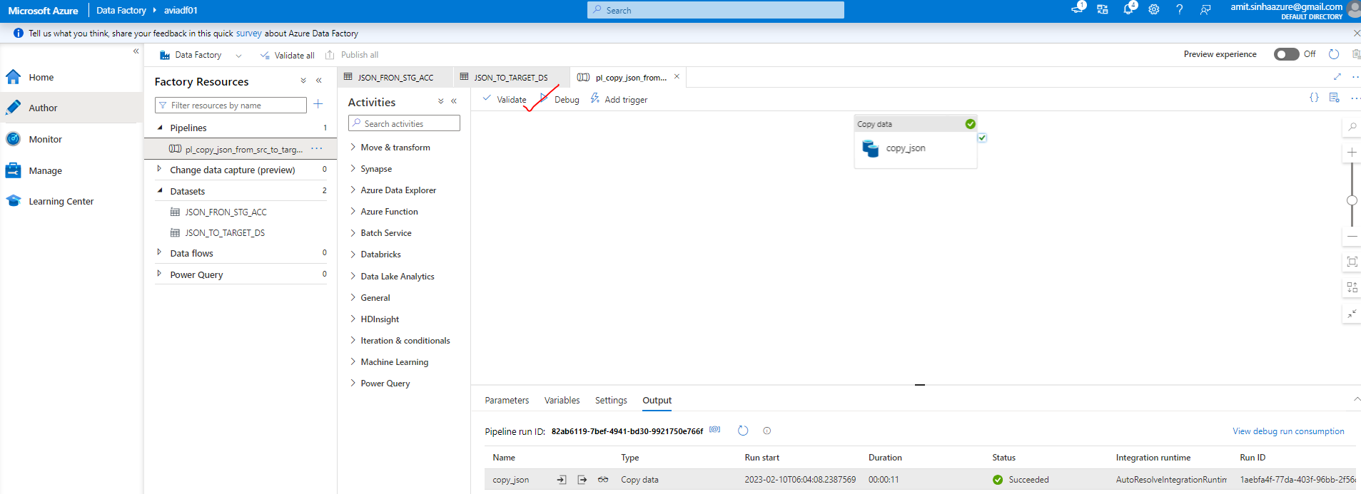

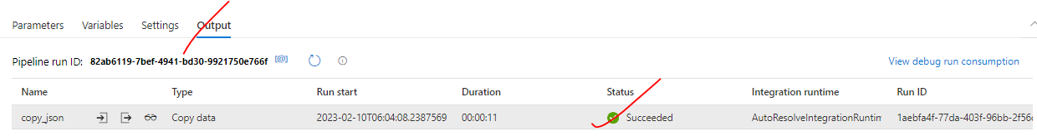

#### USECASE 2: COPY THE FILES ONLY IF ITS NOT PRESENT IN TARGET CONTAINER OF STORAGE ACCOUNT

* Here we will make use of “Parameters”(Pipeline / Dataset dynamic parameters)

|  |  |
| --- | --- |
| **If(fileExist){**  **Do not copy**  **}else {**  **Copy the file**  **}** | * In the above use case – we copied / overridden the file in the target container. In this use case we want to copy the data only if the file is not present. * To extend the pipeline further- We can clone the existing pipeline and make changes in it. |

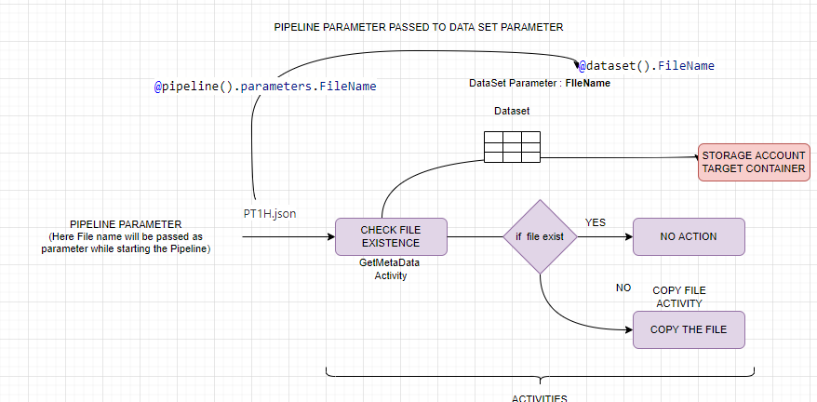

**CONCEPT**

* When we trigger a pipeline – We can pass the value to activities using pipeline parameter
* The passed value to activity will be received by dataset parameter.

**STEP 1: ADD A NEW ACTIVITY CALLED “*Get Metadata*”**

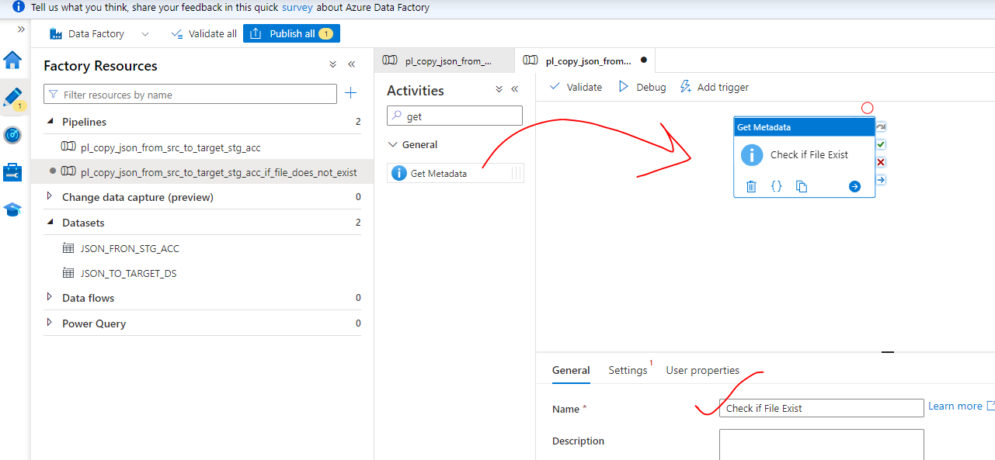

**Step 2: CREATE A NEW DATA SET –**

* The new data set will be on the target side to check the file existence in the target container of storage account.

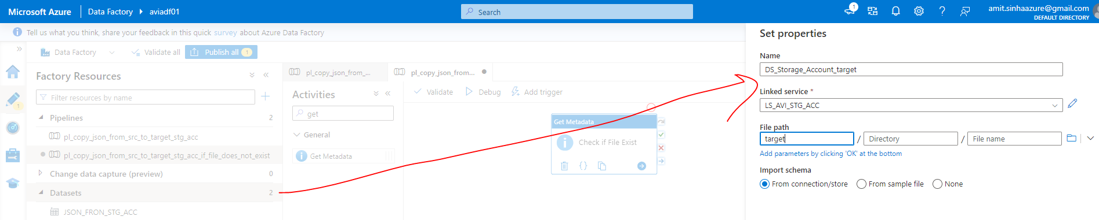

**STEP 3: ADD A “*FILENAME*” DATASET PARAMETER.**

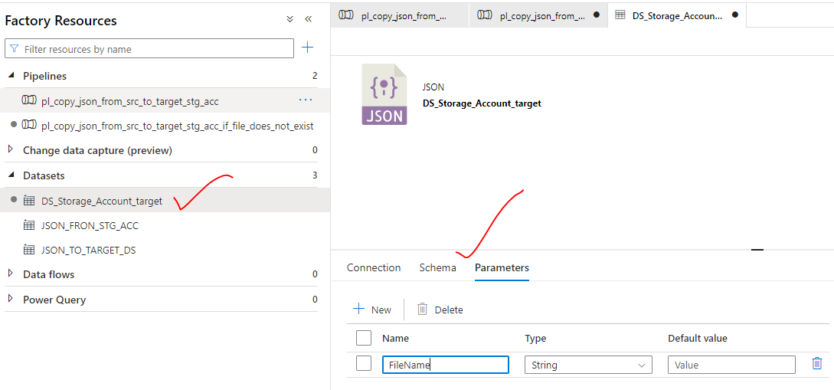

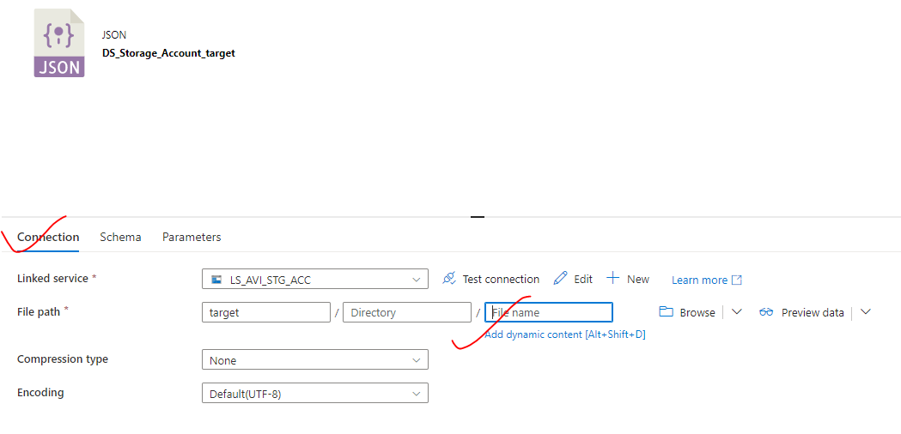

* The pipeline will pass the value to the dataset parameter called - “FileName ” dynamically

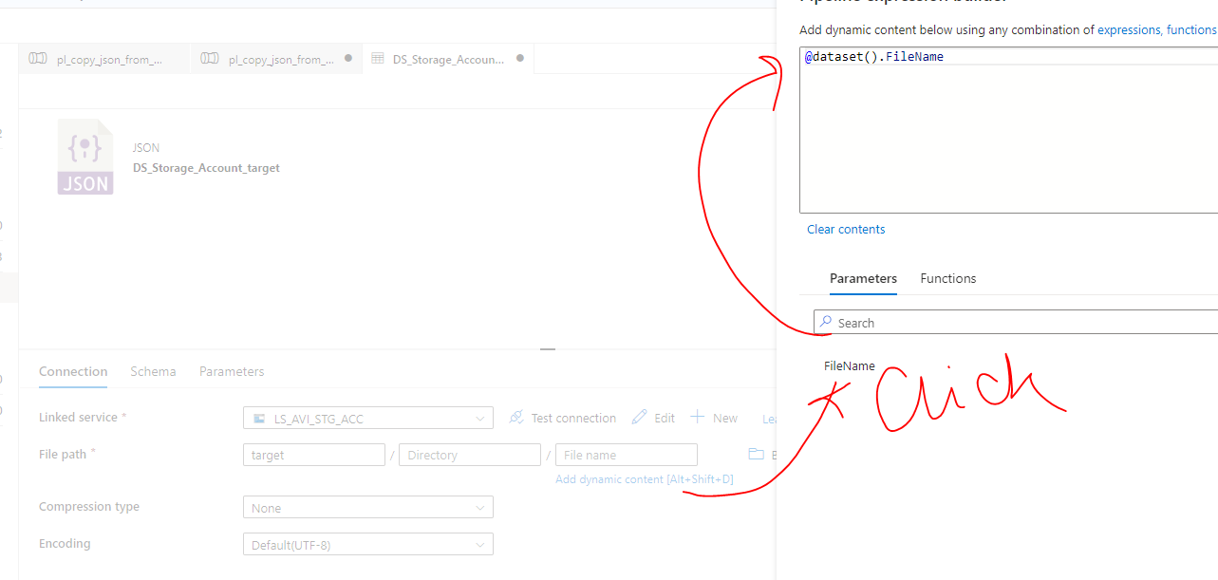

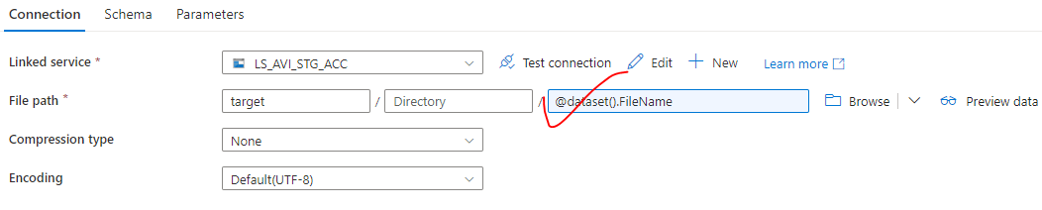

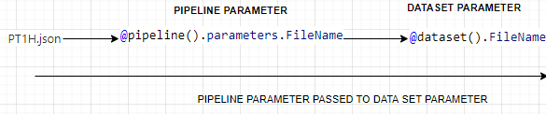

**SETTING UP PIPELINE PARAMETER**

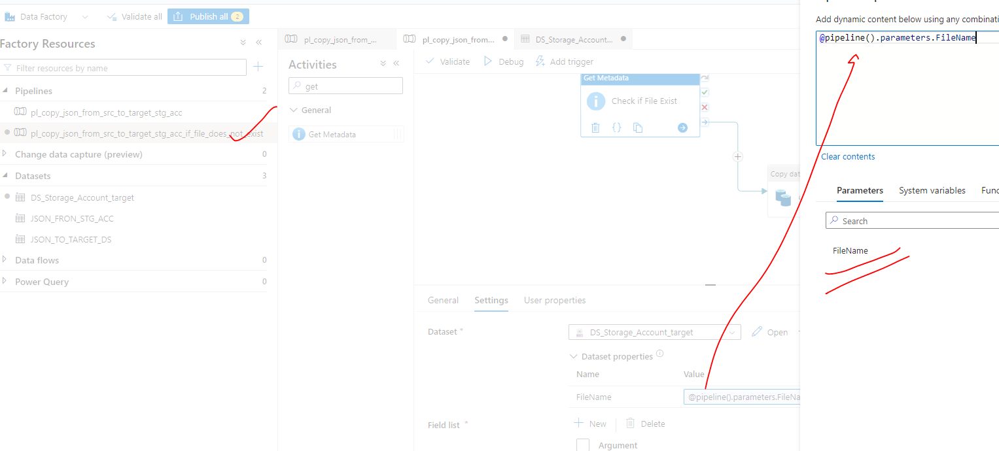

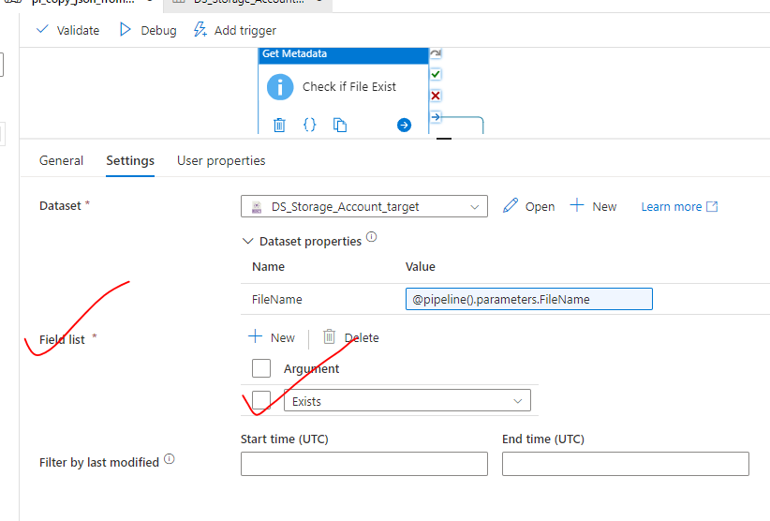

|  |  |
| --- | --- |
|  | **DEBUGING AN ACTIVITY –** An activity can be debugged in isolation (using red dot – Debug until Option) |

**RUNNING THE PIPELINE**

We need to pass the value(filename) while debugging / running the pipeline

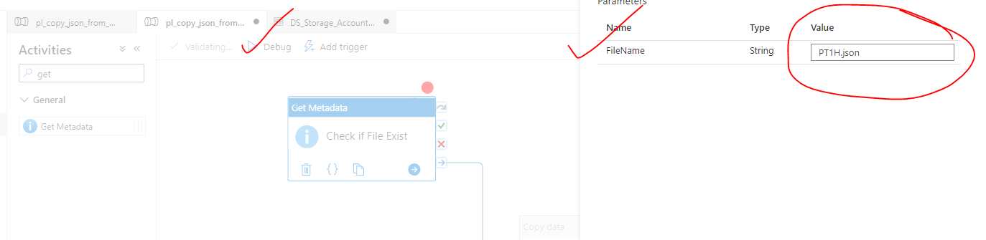

|  |  |
| --- | --- |
|  | * Testing succeeded |

|  |  |
| --- | --- |
|  | * This is the output of the GetMeta Data activity. * The output value “exist=true” will be passed to the “if condition” activity * if the condition is true 🡪 the file will be copied to target container otherwise no action. |

**ADDING IF CONDITION ACTIVITY**

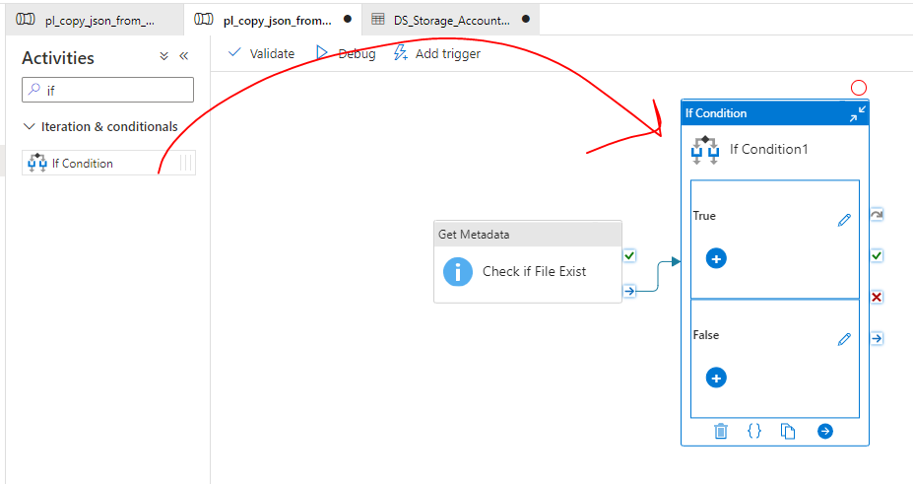

**IF CONDITION ACTIVITY PAREMETER**

* The exist property value from the previous activity (*GetMetaData*) – [@activity('Check if File Exist').output.exists]- will be used in if condition metadata

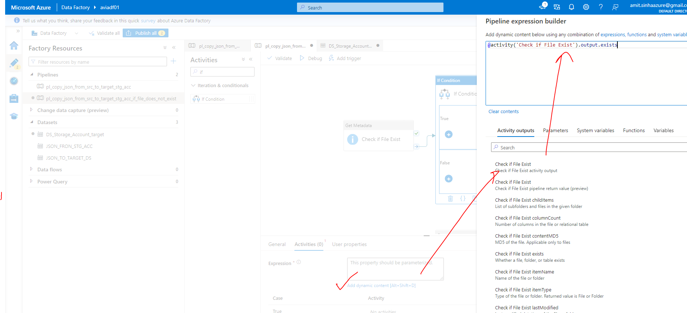

* Cut the copy data activity to the else block of the “if condition” activity

|  |  |
| --- | --- |
|  |  |

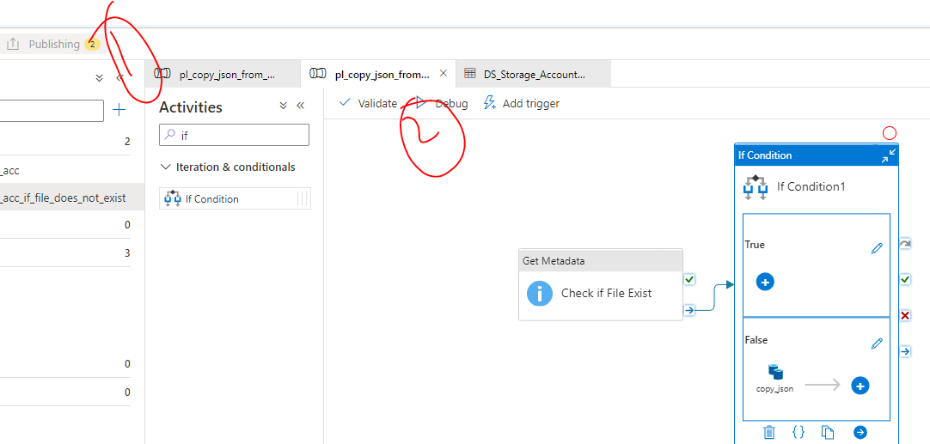

|  |  |
| --- | --- |
|  | * Passing a value to a pipeline |

**OUTPUT – *When the file is present – it executes three activities***

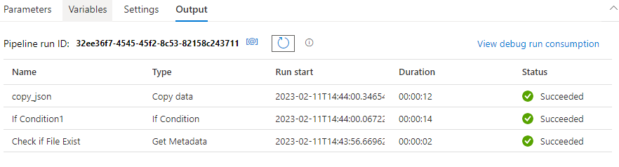

### SETTING UP GITHUB IN ADF

|  |  |
| --- | --- |
|  | * To Configure GitHub for ADF -🡪 Go to Git Configuration |
|  | |
|  | |

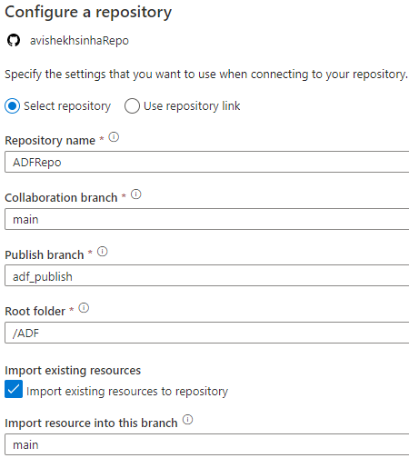

# AZURE EVENT HUB AND STREAM ANALYTICS

## BATCH AND REAL TIME PROCESSING

### BATCH PROCESSING

In case of data-factory we do a batch processing of data (ETL). Usually in case of **batch processing**

* We take large amount of data from the source (e.g., storage account) 🡪 Transform It 🡪 Load the data in the destination data store (Azure Synapse)
* OR - take large set semi-structured files and then process them into structured files that can be used for future analysis.
* Example – Webserver logs that are copied to Azure data lake Gen2 storage account over the day, Then the batch process kicks in and sends the data to an Analytical store for daily reporting purpose.

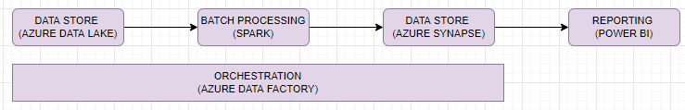

### REAL TIME PROCESSING

* In Real time processing – streams of data are captured in real time and processed with minimal latency to generate real-time reports
* Processing of data needs to be done as fast as possible so that it does not block the incoming stream of data
* The platform should be available to ingest large amount of data at fast rate.



## AZURE EVENT HUB

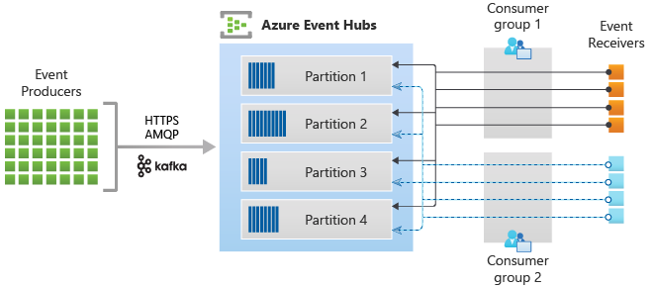

* Azure event hub is big data streaming platform
* This service can receive and process **millions of event/sec**. We can stream data like- log data, telemetry data etc.
* The sources produce the events and send it onto Azure event hubs. (e.g., Web server that is continuously streaming the log data)
* At the other end – we can have a receiver - This can be a program that is taking in all the data that is being sent onto Azure event hubs. The event receivers can take the data and process the data accordingly.
* **PARTITION IN EVENT HUBS** –
  + In Azure event hubs, we have multiple partitions. the main purpose of having a partition is to ingest more data at a time.
  + We can have data in multiple partitions and the event receivers can take in the data either from one partition or from all partitions. So, this helps in taking in the data at a fast rate with the help of partitions
  + We can have multiple event receivers that are taking in the data in panel from the different partitions - So that we could consume the data at a very fast rate.

### COMPONENTS OF AN EVENT HUB

|  |  |
| --- | --- |
| EVENT PRODUCER | * This is an entity that sends data to an event hub. The events can be published using protocols – HTTPS, AMQP , Apache Kafka |
| PARTITIONS | * The data is split across multiple partitions. This allows better throughput of the data |
| CONSUMER GROUP |  |
| THROUGHPUT | * This is the throughput capacity of event hub |
| EVENT RECIEVER | * Entity that reads the event data |

### CREATING AN EVENT HUB INSTANCE

* STEP 1 - CREATE EVENT HUB NAMESPACE NAME SPACE

|  |  |
| --- | --- |
|  | * Pricing Tier - <https://azure.microsoft.com/en-in/pricing/details/event-hubs/#pricing> |

**UNDERSTANDING THE PRICING TIER**

|  |  |
| --- | --- |
| INGRESS EVENT | Number of events that can be sent to event hub |
| MAX RETENTION PERIOD | How long the event can be retained in the event hub. Till this time the consumer group can read the data from event hub |
| STORAGE RETENTION |  |

* The messaging system in Event Hub different from other messaging systems. In normal messaging system - when we read a message from the system - it deletes the message from the source. But in case of event hubs – Instead of messages the events get stored in the EH. That's because we can have multiple consumers that could be reading events for different purposes.

**STEP 2 🡪 CREATE EH IN THE NAME SPACE.**

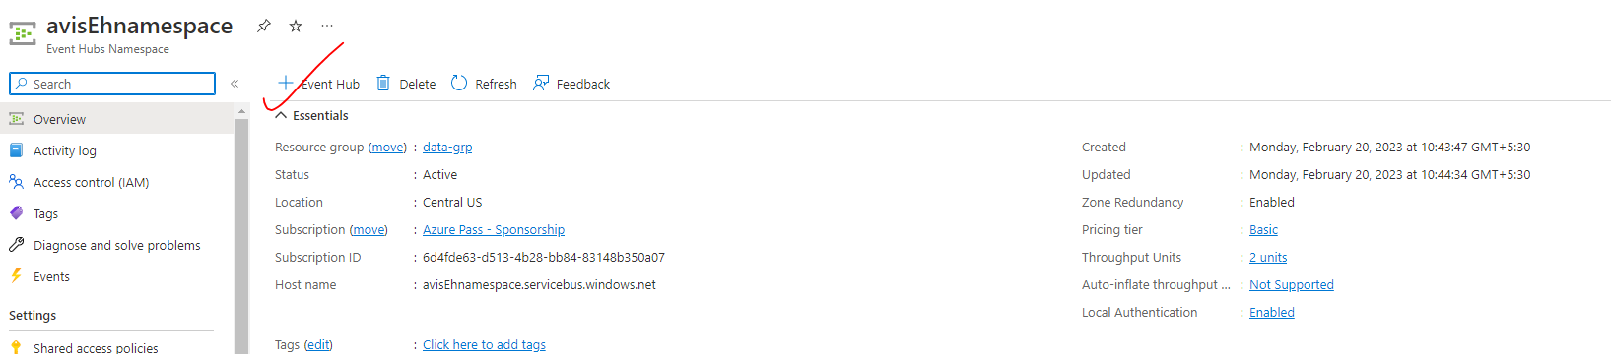

|  |  |
| --- | --- |
|  | * Retention Time - This is the amount of time that the message will be retained in the Event Hub. * Note - there is no manual way of deleting the events from the Event Hub. * It needs to expire based on the setting   that we put for the message retention. |

### USE CASE(EXAMPLE)

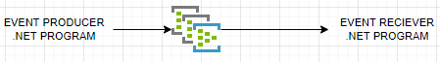

* This will be simple example on how we can use a .net program to send events onto the event hub and how do we use another .Net program to receive events from the event hub.
* Sender Program will create a list of orders.

|  |  |
| --- | --- |
| INPUT FROM SENDER PROGRAM |  |
| OUTPUT FROM SENDER PROGRAM |  |

#### CONNECTING THE PROGRAM WITH EVENT HUB

* To connect with the event hub – we need to make use of connection string. For the connection string 🡺 Go the Event hub 🡪 Shared Access Policies 🡪 Add

We need to create 2 SAS Policies(this policy will have the permission of sending events onto the event hub)

* + One for sending the events to EH
  + One to consume events from EH(Listen)

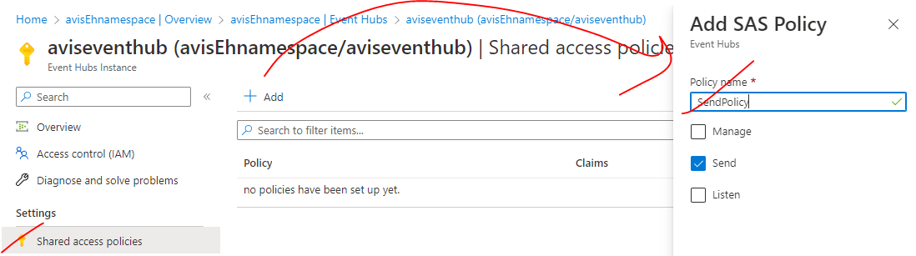

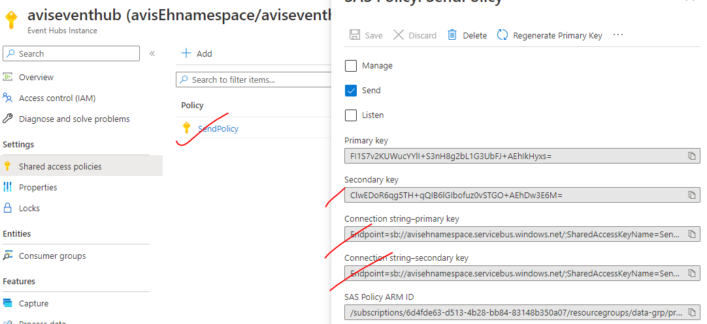

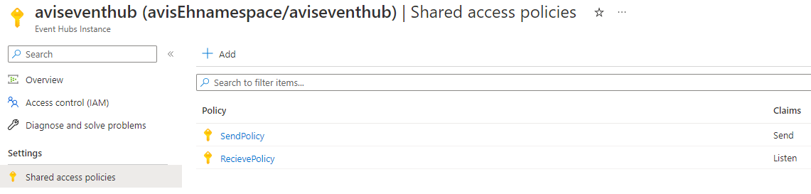

* After reading all the events – the events are not deleted (it depends on the retention policy). Hence the same data can be read again. The receiver program can send the to another data store.

**Note**

* Azure Event Hub is used to ingest data. It takes the data that can come from multiple data sources. Then we can have another program that will take the data and let's say store it in Data Lake Gen two storage account for further processing or maybe in Azure synapse.

##### SETTING UP CONSUMER GROUP

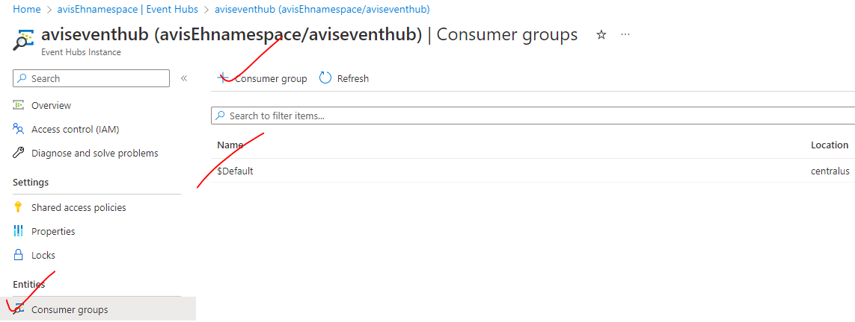

## AZURE STREAM ANALYTICS

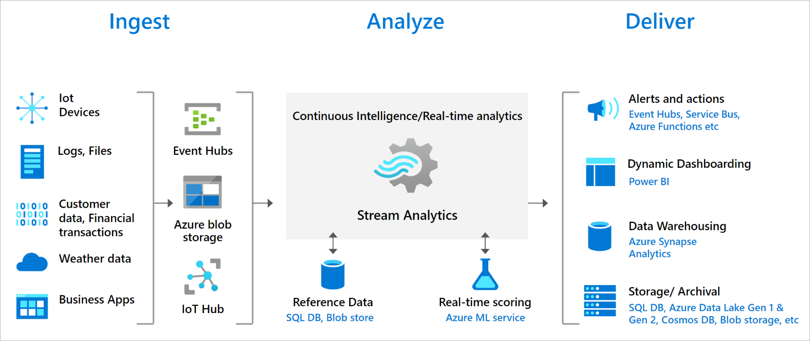

* Azure Stream Analytics is a real time analytics and event processing service.

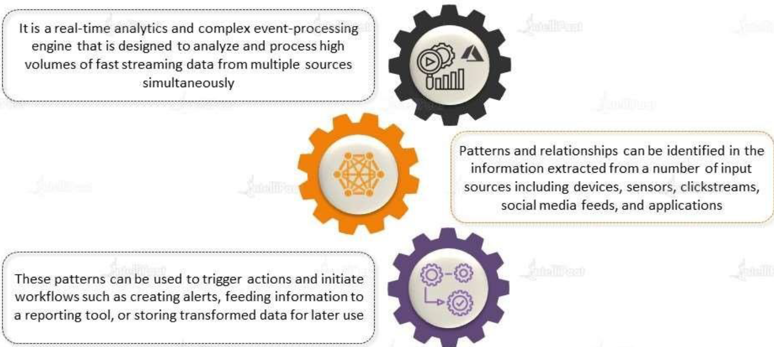

|  |  |
| --- | --- |
| INGEST | The ingestion of data can be from multiple sources like IOT devices, log files or from SAS based applications |
| ANALYZE | We can use services such as Azure event hubs or data might be copied directly onto a Azure blob storage. We can also use a Azure IOT hubs to take the data from IOT based devices. |
| DELIVER | * Then we have Azure Stream Analytics that takes that data that is being ingested into event hubs or onto IOT hubs. * The data is then can be analyzed - in real time and then we could store that data or transfer that data onto a destination data store. For example, Azure SQL data warehouse or Azure Datalake Gen 2 storage account * We can also look at that data using Power BI. |

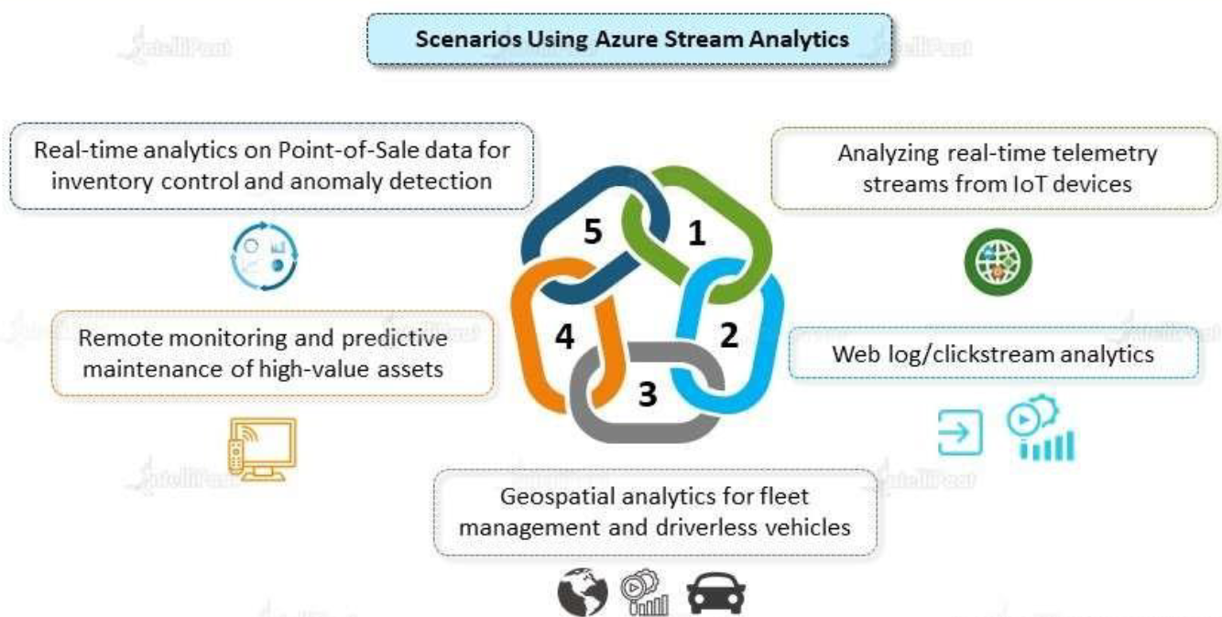

### CREATING A STREAM ANALYTICS JOB

* Search for “Stream Analytics Job”

|  |  |
| --- | --- |
|  |  |
| STREAMING UNITS |  |

#### INPUT, OUTPUT AND QUERY

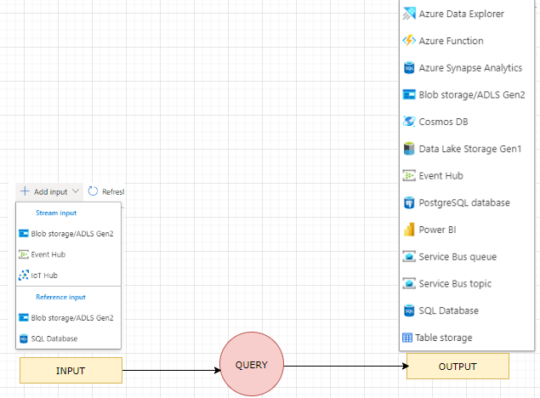

* INPUT: **EVENT HUB**
  1. It creates a new consumer group and Event hub policy

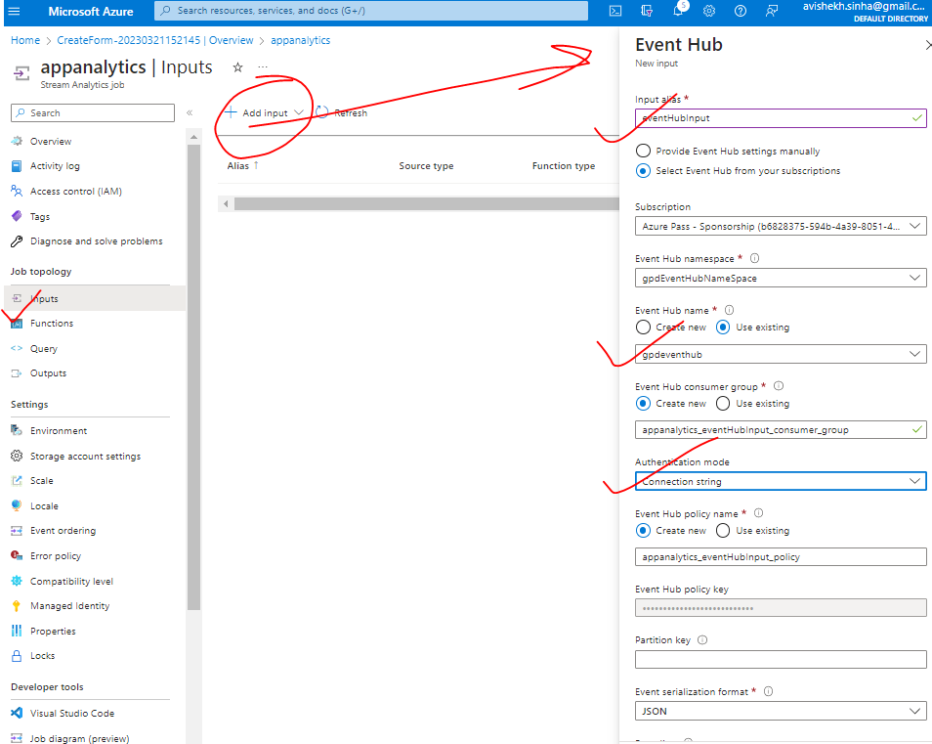

* OUTPUT: **SQL TABLE**

|  |  |
| --- | --- |
| CREATE A TABLE | CREATE TABLE [dbo].[Orders]  (  [OrderID] varchar(10),  [Quantity] int,  [UnitPrice] decimal(5,2),  [DiscountCategory] varchar(10)  ) |
| CONFIGURE THE AZURE SYNAPSE ANALYTICS AS AN OUTPUT |  |

# COSMOS DB

## WHAT IS COSMOS DB

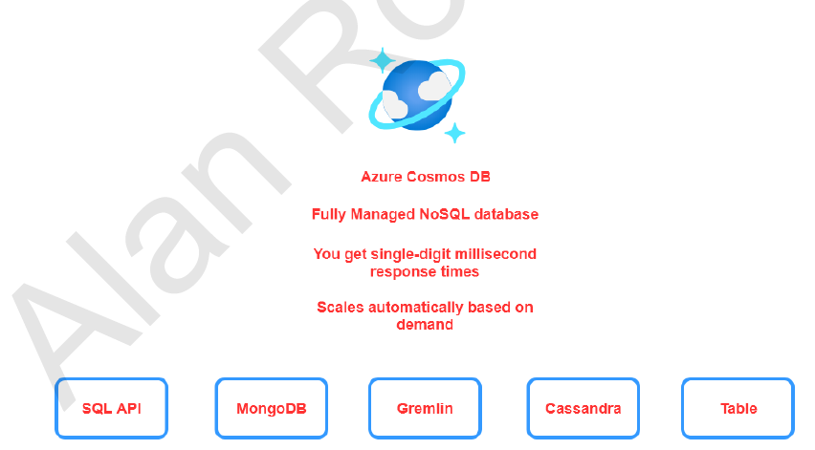

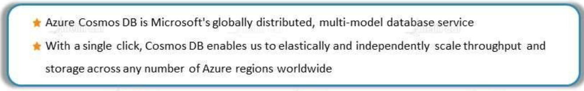

**Cosmos DB is planet-scale, NO SQL and JSON database with multi-API support**

FEATURES

* + Fast response time.
  + The infrastructure automatically scales based on demand.
* There are also different APIs available when it comes to Cosmos DB. When we create Azure Cosmos DB account, at that point in time, we will choose the API depending upon the API that we choose. The data get stored based on that API. For example, if we want to store JSON based documents in Cosmos DB and if we want to use SQL based command (for querying data) – we can go ahead and use the SQL API.

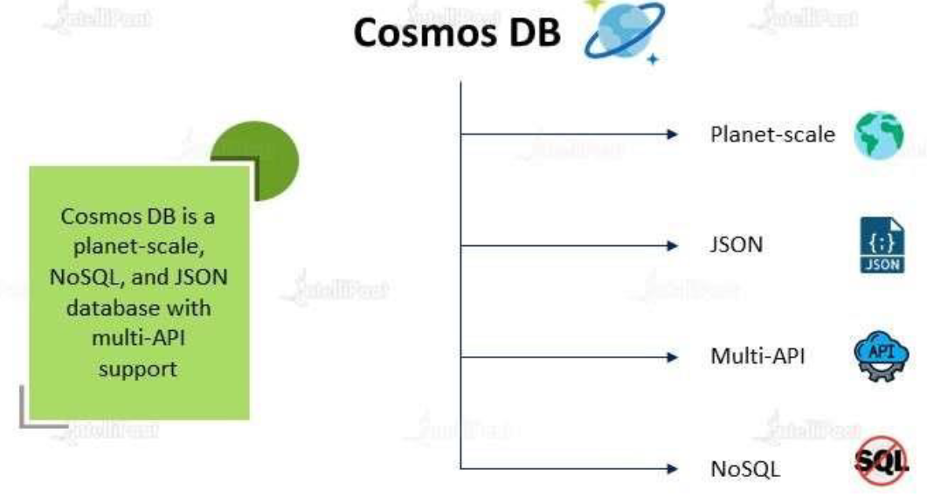

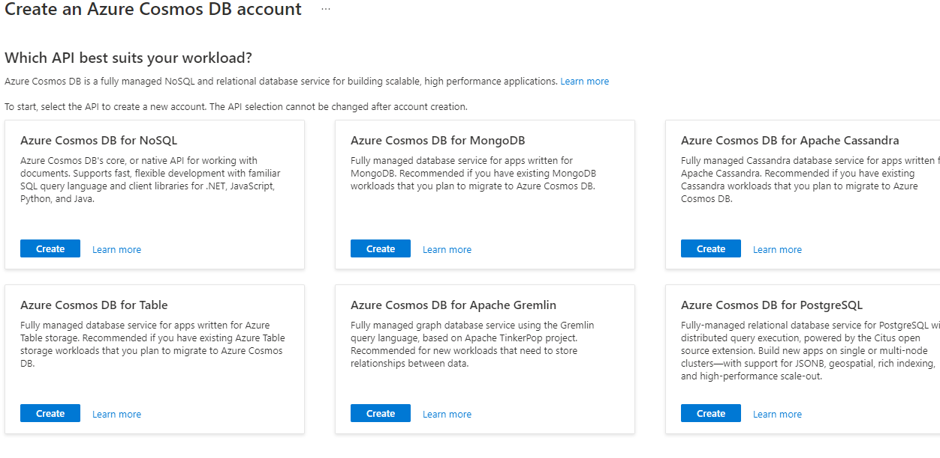

### WHAT IS PLANET SCALE DATABASE?

|  |  |
| --- | --- |
|  |  |

* Suppose we have database in US and there are users who are using it across the globe. Any user who is accessing the data will be faster as compared to other geolocation. Hence , the performance will not be up-to the mark when it comes to location other than US
* In such cases – we can set up a secondary DB(readonly DB) – wherever we have our user base. Meanwhile the primary DB (write DB) is in the US.
* When someone writes in US DB, the replication of It sent to the secondary DB- that are placed in other geographical areas.

#### ISSUE WITH PLANET SCALE DATABASE

|  |  |
| --- | --- |
|  | * One of the biggest problems to achieve planet scale Db architecture in inconsistency i.e. Before synchronization finishes, if an end user reads the data from US DB, he/she would see a different data as compared to the user who reads from Africa DB. |

## CONSISTENCY MODEL IN COSMOS DB

|  |  |
| --- | --- |
| Azure Cosmos DB offers five levels from consistency levels. From strongest to weakest, the levels are:   * [STRONG](https://learn.microsoft.com/en-us/azure/cosmos-db/consistency-levels#strong-consistency) * [BOUNDED STALENESS](https://learn.microsoft.com/en-us/azure/cosmos-db/consistency-levels#bounded-staleness-consistency) * [SESSION](https://learn.microsoft.com/en-us/azure/cosmos-db/consistency-levels#session-consistency) * [CONSISTENT PREFIX](https://learn.microsoft.com/en-us/azure/cosmos-db/consistency-levels#consistent-prefix-consistency) * [EVENTUAL](https://learn.microsoft.com/en-us/azure/cosmos-db/consistency-levels#eventual-consistency) |  |

When we start using Cosmos DB. We create following

|  |  |  |  |  |  |  |  |
| --- | --- | --- | --- | --- | --- | --- | --- |
|  | |  |  | | --- | --- | | COSMOS DB ACCOUNT | * While create the cosmos db account we choose the type of API we are going to use | | DATABASE | * Within the DB account we create DBs | | CONTAINER | * Within the database you create something known has a container, and within that container we will have items. | |

Note - Depending upon the API that we choose. The DB, container and items are termed differently

|  |  |  |  |
| --- | --- | --- | --- |
| **API** | **DATABASE TERM** | **CONTAINER TERM** | **ITEM TERM** |
| SQL API | Database | Container | Item |
| MONGO DB | Database | Collection | Document |
| GREMLIN | Database | Graph | Node/Edge |
| CASSANDRA | Keyspace | table | Row |
| TABLE | NA | Table | Items |

## COSMOS DB PARTITION

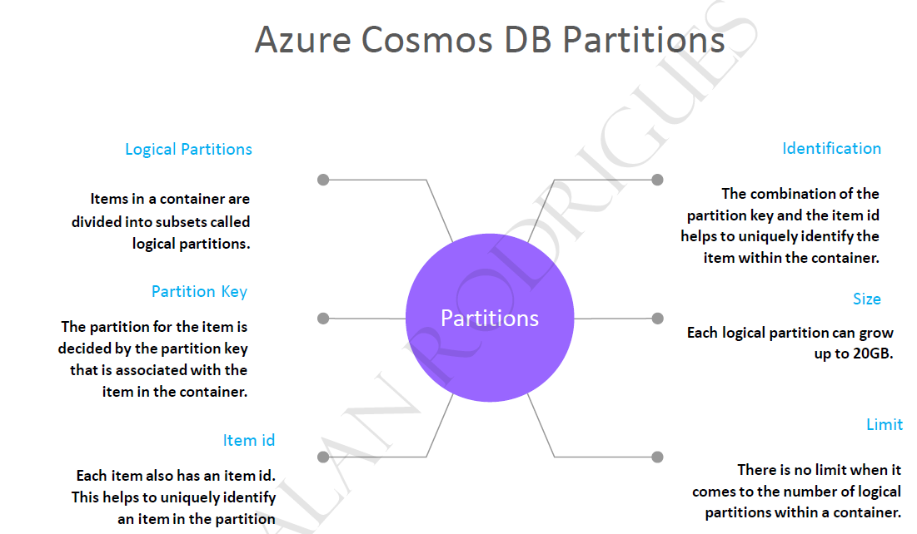

## PARTITIONS KEYS

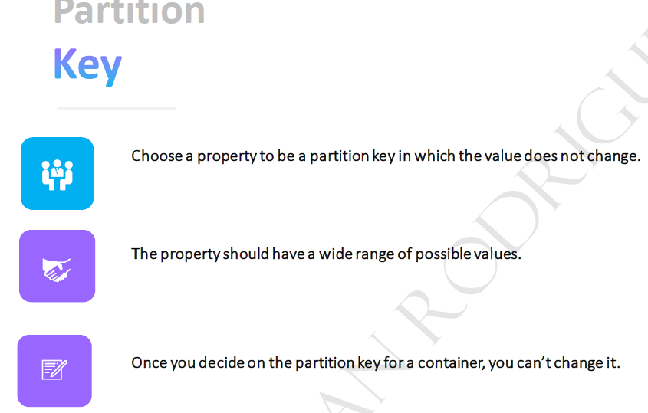

## COSTING IN COSMOS DB

* The cost of database operations for cosmos DB is measured in terms of request units.
* **Request units is a measure of the CPU, the IOPS and the memory. Hence instead of charging separately when it comes onto the CPU, the IOPS and the memory, everything is taken as a single measure and that's called request units**
* The RU varies based on type of operation we are doing. For example, RU charged for writing data is higher than reading
* When you are creating as the Cosmos TV account, there are different options that you can choose when it comes to provisioning or throughput or request units.
  + PROVISION THROUGHPUT
    - We specify the number of request units that need to be allocated.
    - At any point in time, you can always increment or decrement the number of request units.
    - We are billed on hourly basis
    - We can provision either on the DB level or container level
  + SERVERLESS
    - We don’t mention any throughput.
    - The throughput that's allocated, is managed completely by the service itself - depending upon the demand, it'll go out and provision. We are billed based on the request units that we consume.
  + AUTO SCALE MODE
    - The request units can automatically scale based on demand.
    - The demand is checked both at the container level and at the database level.
    - This is great when it comes onto mission critical workloads

## SETTING UP A COSMOS DB

### SETTING UP COSMOS DB ACCOUNT

1. SELECT AN API. Let’s select Azure Cosmos DB for No SQL

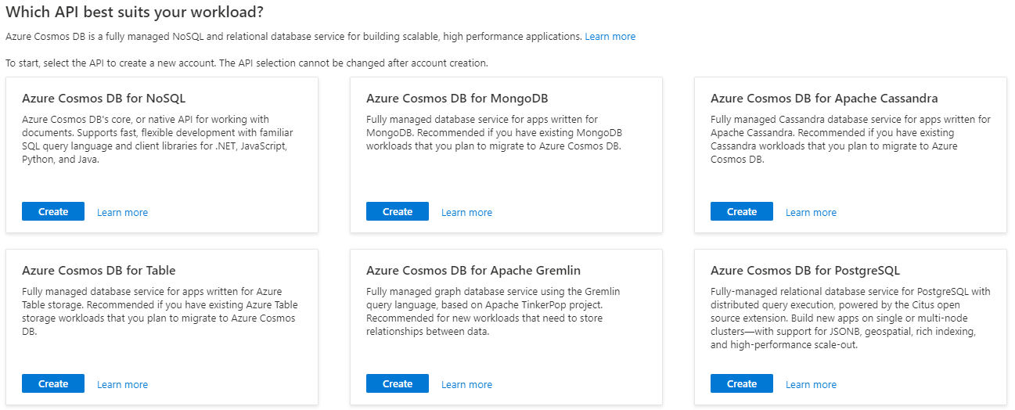

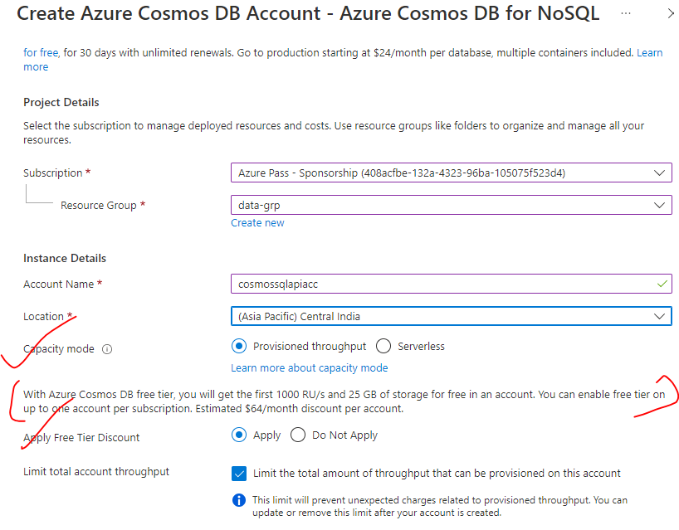

* Geo-Redundancy – This enable the redundancy of data across multiple location
* Multi-Region Writes – This enables the write operation of secondary location as well.. Disabing means – the data will be written in primary location and replicated to secondary locations.

#### GLOBAL DISTRIBUTION

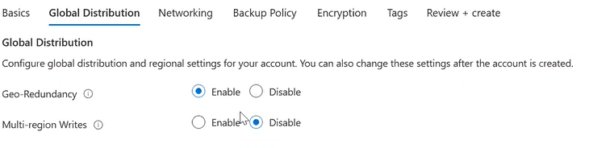

#### BACKUP POLICY

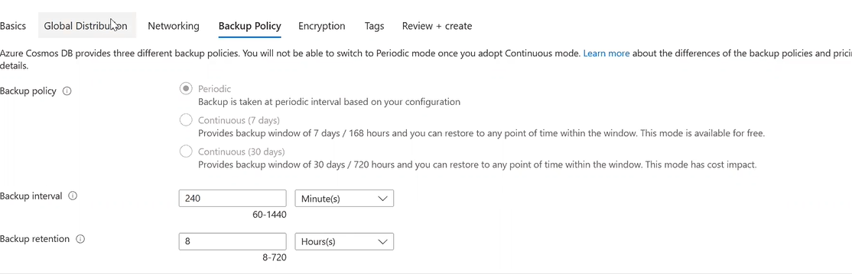

### DATA EXPLORER – COSMOS DB

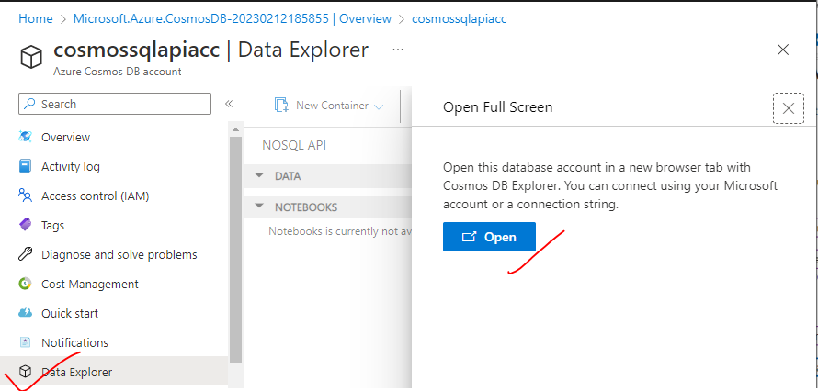

### CREATING COSMOS DB

* CREATE NEW DATABASE

|  |  |
| --- | --- |
|  |  |

* CREATE A CONTAINER INSIDE THE DB

|  |  |
| --- | --- |
|  |  |

### USE CASE

1. In this usecase – We will pull the data from upstream system (orders table) 🡪 to cosmos Db using ADF pipeline

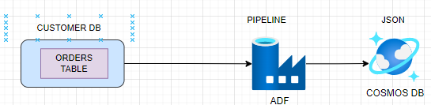

|  |  |
| --- | --- |
| STEP 1: CREATE A LINKED SERVICE OF TYPE SQL DATABASE | STEP 3: CREATE A LINKED SERVICE OF TYPE COSMOS DB NO SQL |
| STEP 3: CREATE A DATASET FOR SQL DB(INPUT DATASET)  TYPE - Azure SQL Database | STEP 4: CREATE A DATASET FOR COSMOS DB(OUTPUT DATASET)  TYPE - Azure Cosmos Db NoSQL Database |
| STEP 5: CONFIGURE THE TABLE IN THE CONNECTION PROPERTY 🡪 PUBLISH ALL | |

STEP 6 – CREATE A PIPELINE TO COPY THE SQL DB TABLE DATA TO COSMOS DB CONTAINER)

1. Set up the source and Target dataset for the copy data activity

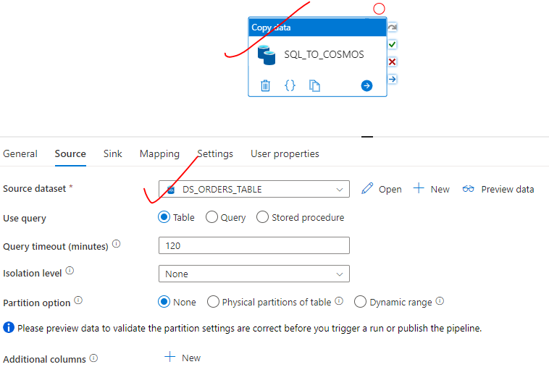

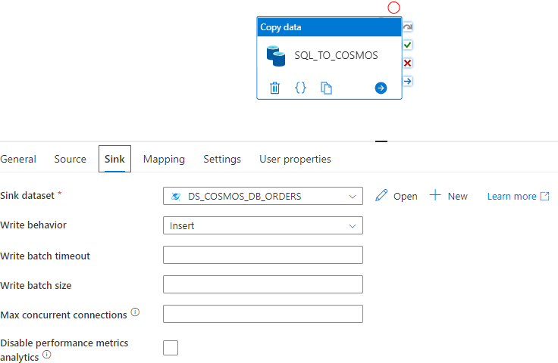

|  |  |
| --- | --- |
| STEP 7 – MAP THE TABLE COLUMN  Import the SQL table schema (We can be able to import the schema from structured database)  Publish All 🡪 Debug |  |

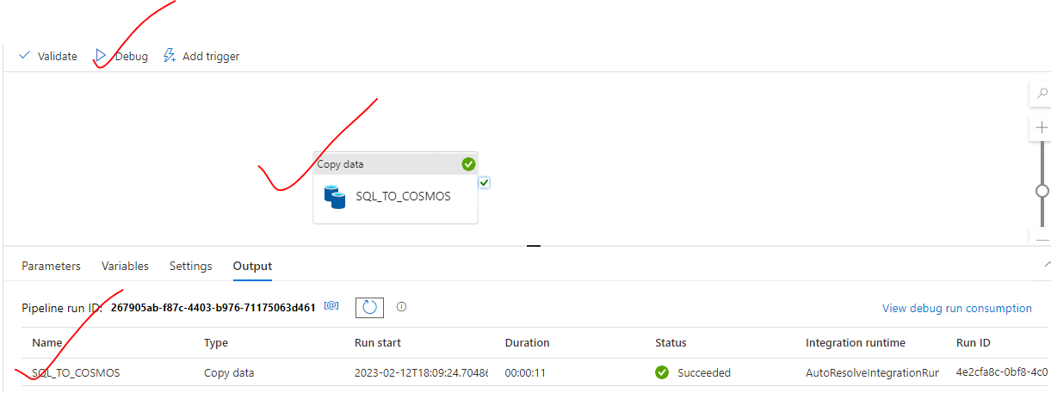

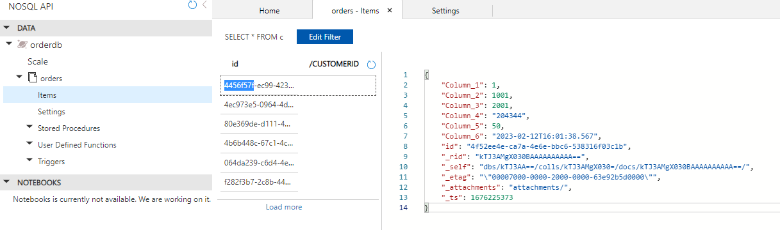

# APACHE SPARK – OVERVIEW

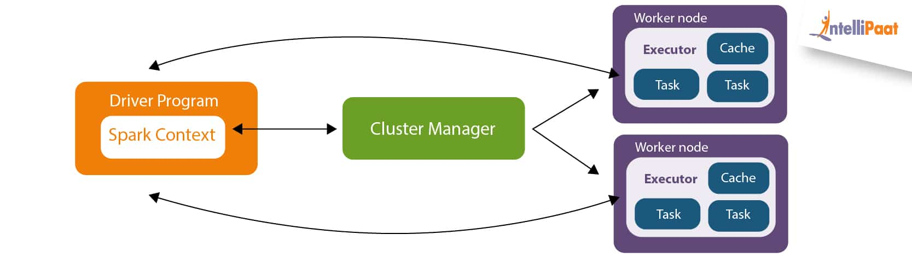

* Spark system is built using several separate machines who all work together towards a common goal, this is referred to as **a cluster or distributed system.**
* **The driver node+ Worker node are called Cluster. The machine which manages the cluster are called driver node.**

## DRIVER NODE

* The Spark driver is used to orchestrate the whole Spark cluster, this means it will manage the work which is distributed across the cluster as well as what machines are available throughout the cluster lifetime.

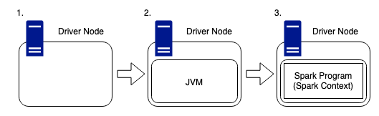

* The driver node is like any other machine, it has hardware such as a CPU, memory, DISKs, and a cache, however, these hardware components are used to host the Spark Program and manage the wider cluster. The driver is the users link, between themselves, and the physical compute required to complete any work submitted to the cluster.
* As Spark is written in Scala, it is important to remember that any machine within the cluster needs to have a JVM (Java Virtual Machine) running, so that Spark can work with the hardware on the host.
* The Spark Program runs inside of this JVM and is used to create the **SparkContext**, which is the access point for the user to the Spark Cluster.
* The driver contains the DAG (Directed Acyclic Graph) scheduler, task scheduler, backend scheduler and the block manager. These driver components are responsible for translating user code into Spark jobs executed on the cluster. **Hidden away within the driver node is the cluster manager, which is responsible for acquiring resources on the Spark cluster and allocating them to a Spark job. These resources come in the form of worker nodes.**

## WORKER NODE(S)

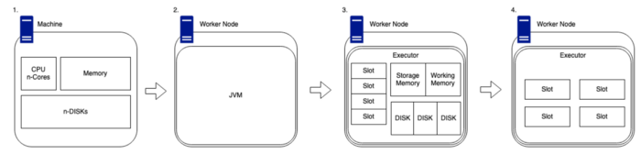

1. Worker nodes are generally stand-alone machines which have hardware like any other. Such as a CPU, memory, disks, and a cache.
2. As with the driver, for Spark to run on a worker node, we need to ensure that the system has a compatible version of Java installed so that the code can be interpreted in the correct and meaningful way.
3. When we have Spark installed on our worker node, our driver node will be able to utilize its cluster management capabilities to map what hardware is available on the worker.
4. The cluster manager will track the number of “slots”, which are essentially the number of cores available on the device. These slots are classified as available chucks of compute and they can be provided tasks to complete by the driver node.
5. There is an amount of available memory which is split into two sections, storage memory and working memory. The default ratio of this is 50:50, but this can be changed in the Spark config.
6. Each worker also has several disks attached. **Spark works in memory, not disk**! However, Spark still needs disks to allocate shuffle partitions (discussed further, later in this article), it also needs space for persistence to disk and spill to disk.

## MINIMISED PHYSICAL STRUCTURE

* The Driver node is the central hub for communication between nodes in the cluster.

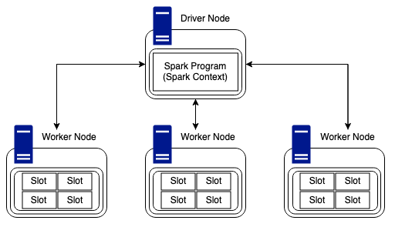

* Worker nodes can communicate and pass data between each other but regarding work and tasks, the Driver node is solely responsible for providing Workers with jobs to complete.
* With the example above, we have a cluster containing a driver, and three worker nodes. Each node has four slots of compute available, so, this cluster would be able to complete twelve tasks in unison.

## SPARK RUNTIME ARCHITECTURE

* The Spark runtime architecture is exactly what it says on the tin, what happens to the cluster now of code being run. Well, “code being run” might be the wrong phase. Spark has both eager and lazy evaluation. Spark actions are eager; however, transformations are lazy by nature.
* As stated above, transformations are lazy, this essentially means when we call some operation on our data, it does not execute immediately. Spark maintains the record of which operation is being called. These operations can include joins and filters.
* Actions are eager, which means that when an action is called, the cluster will start to compute the expected results as soon as the line of code is run. When Actions are run, they result in a non-RDD (resilient distributed dataset) component.

TYPES OF TRANSFORMATIONS:

There are two types of transformations which are key to understanding how Spark manages data and computes in a distributed manner, these are **narrow** and **wide**. Transformations create RDDs from each other.

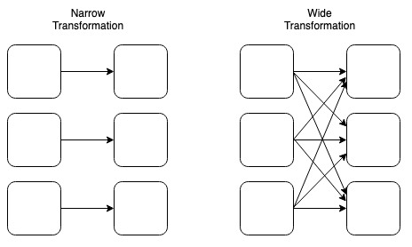

Narrow and Wide Transformations (created by Luke Thorp)

Narrow Transformations are defined by one input partition will result in one output partition. An example of this could be a filter: as we can have a data frame of data which we can filter down to a smaller dataset without the need to understand any data held on any other worker node.

Wide transformations (shuffles) are defined by the fact the worker nodes will need to transfer (shuffle) data across the network to complete the required task. An example of this could be a join: as we may need to collect data from across the cluster to complete a join of two datasets fully and correctly.

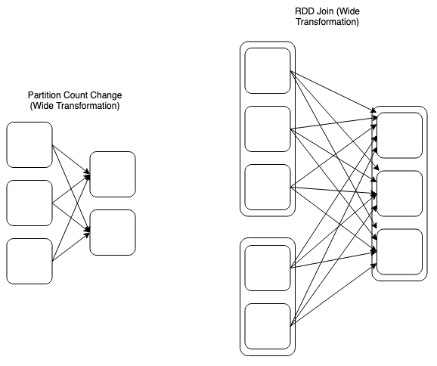

Wide Transformations Extended (created by Luke Thorp)

Wide transformations can take many forms, and n input partitions may not always results in n output partitions. As stated above, joins are classed as wide transformations. So in the instance above, we have two RDD’s which have varying number of partitions being joined together to form a new RDD.

Runtime

When the user submits code to the driver via their preferred method, the driver implicitly converts the code containing transformations (filters, joins, groupby, unions, etc) and actions (counts, writes, etc) into an unresolved logical plan.

At the submission stage, the driver refers to the logical plan catalog to ensure all code conforms to the required parameters, after this is complete the unresolved logical plan is tranformed into a logical plan. The process now performs optimisations, like planning transformations and actions, this optimiser is better know as the catalyst optimiser.

At the core of Spark SQL is the Catalyst optimizer, which leverages advanced programming language features (e.g. Scala’s pattern matching and quasi quotes) in a novel way to build an extensible query optimizer. Catalyst is based on functional programming constructs in Scala and designed with these key two purposes:

- Easily add new optimization techniques and features to Spark SQL

- Enable external developers to extend the optimizer (e.g. adding data source specific rules, support for new data types, etc.)

<https://databricks.com/glossary/catalyst-optimizer>

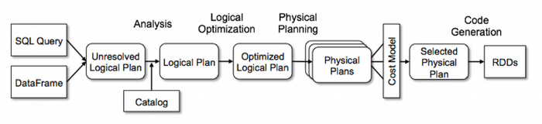

Apache Spark Catalyst Optimiser: Databricks (<https://databricks.com/glossary/catalyst-optimizer>)

I will be doing a deep dive into the catalyst optimiser in the next part of the series, so don’t worry about that part too much.

Once the optimisations are complete, the logical plan is converted into multiple physical execution plans, these plans are funnelled into a cost model with analyses each plan and applies a cost value to run each execution plan. The plan with the lowest cost to complete will be selected as the final output. This selected execution plan will contain job(s) with multiple stages.

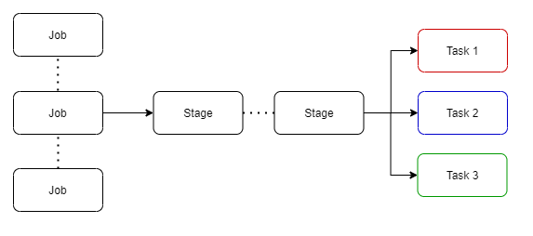

## PHYSICAL EXECUTION PLAN (CREATED BY LUKE THORP)

* Stages have small physical called tasks which are bundled to be sent to the Spark cluster. Before these tasks are distributed, the driver program talks to the cluster manager to negotiate for resources.

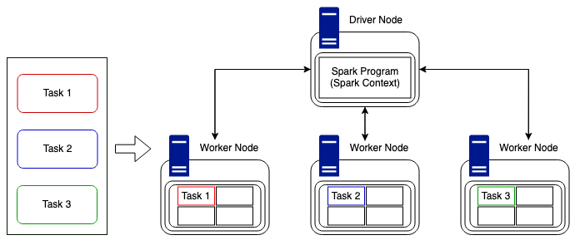

* Once this is done and resources have been allocated, tasks are distributed to the worker nodes (executors) who have free time, and the driver program monitors the progress. This is done in the most efficient way possible keeping in mind the current available resources and the cluster structure. In the above example it is simple, we have three tasks to distribute to three worker nodes. Tasks could be distributed in the way above, i.e., one task to each worker node, or they could be sent to one node and still run asynchronously due to the parallel nature of Spark. But complexity arises when we have more tasks than available slots of compute, or when we have a non-uniformly divisible number of tasks compared to that of the nodes in the cluster. Luckily for us, Spark deals with this itself and manages the task distribution.
* It is worth mentioning, although Spark can distribute tasks in and efficient way, it cannot always interpret the data, meaning, we could encounter data skew which can cause vast time differences in task duration. However, this all depends on how the underlying data lake is structured. If it is built using Delta Engine (Photon) we can take advantage of the live improvement to query execution as well as improvements which encourage better shuffle sizes and optimal join types.
* The Spark UI (user interface) allows the user to interogate the entire workload process, meaning the user can dive into each part. For example, there are tabs for Jobs and Stages. By moving into a stage the user can look at metrics related to specific tasks, this method can be used to understand why specific jobs may be taking longer than expected to complete.

# AZURE DATAFLOW

# AZURE DATABRICK

